Bharath Kumar N(Ps ID:10843180)

Weekly assessment 3 AWS (Linux 1.2)

You are a Cloud Administrator for a startup called LTIM, which is developing a webbased application for its clients. The goal is to host the web application on AWS using EC2 instances, store files in S3, and design a secure and scalable VPC architecture with both public and private subnets.

Questions:

1. Launch an EC2 instance with Amazon Linux 2 in a new VPC and connect via SSH.

Step 1: Open EC2 Service

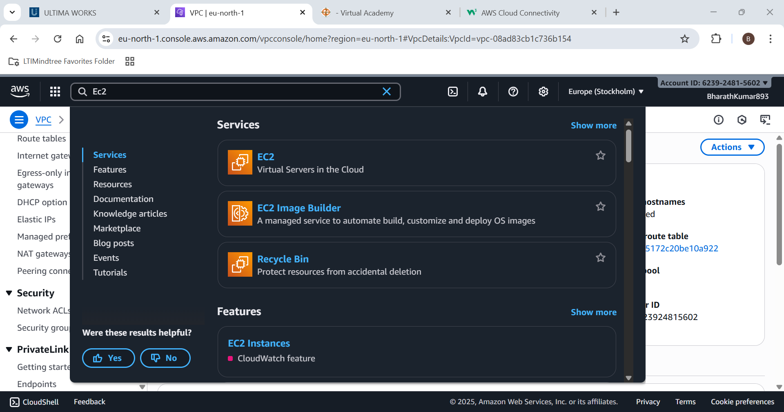

Step 2: Launch an instance .Give name for your EC2 Instance.

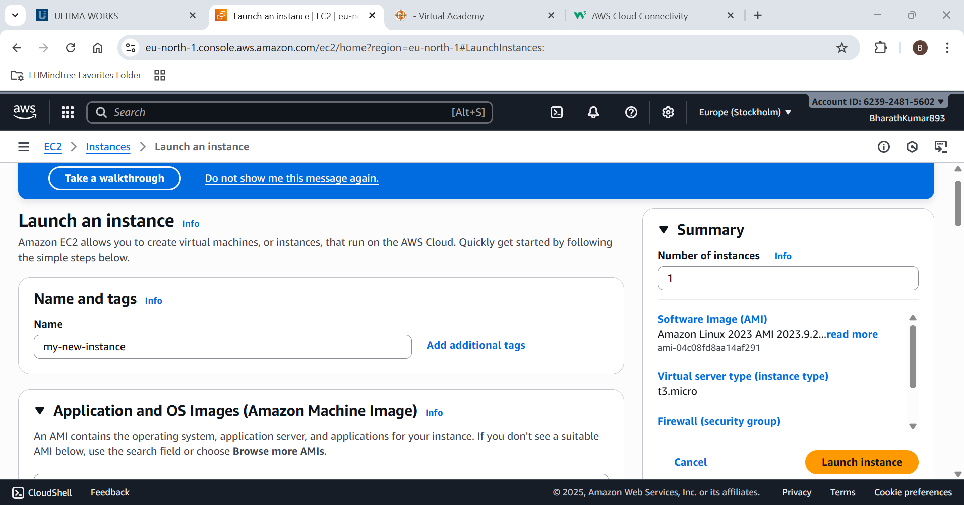

Step 3: Select your AMI as Amazon linux

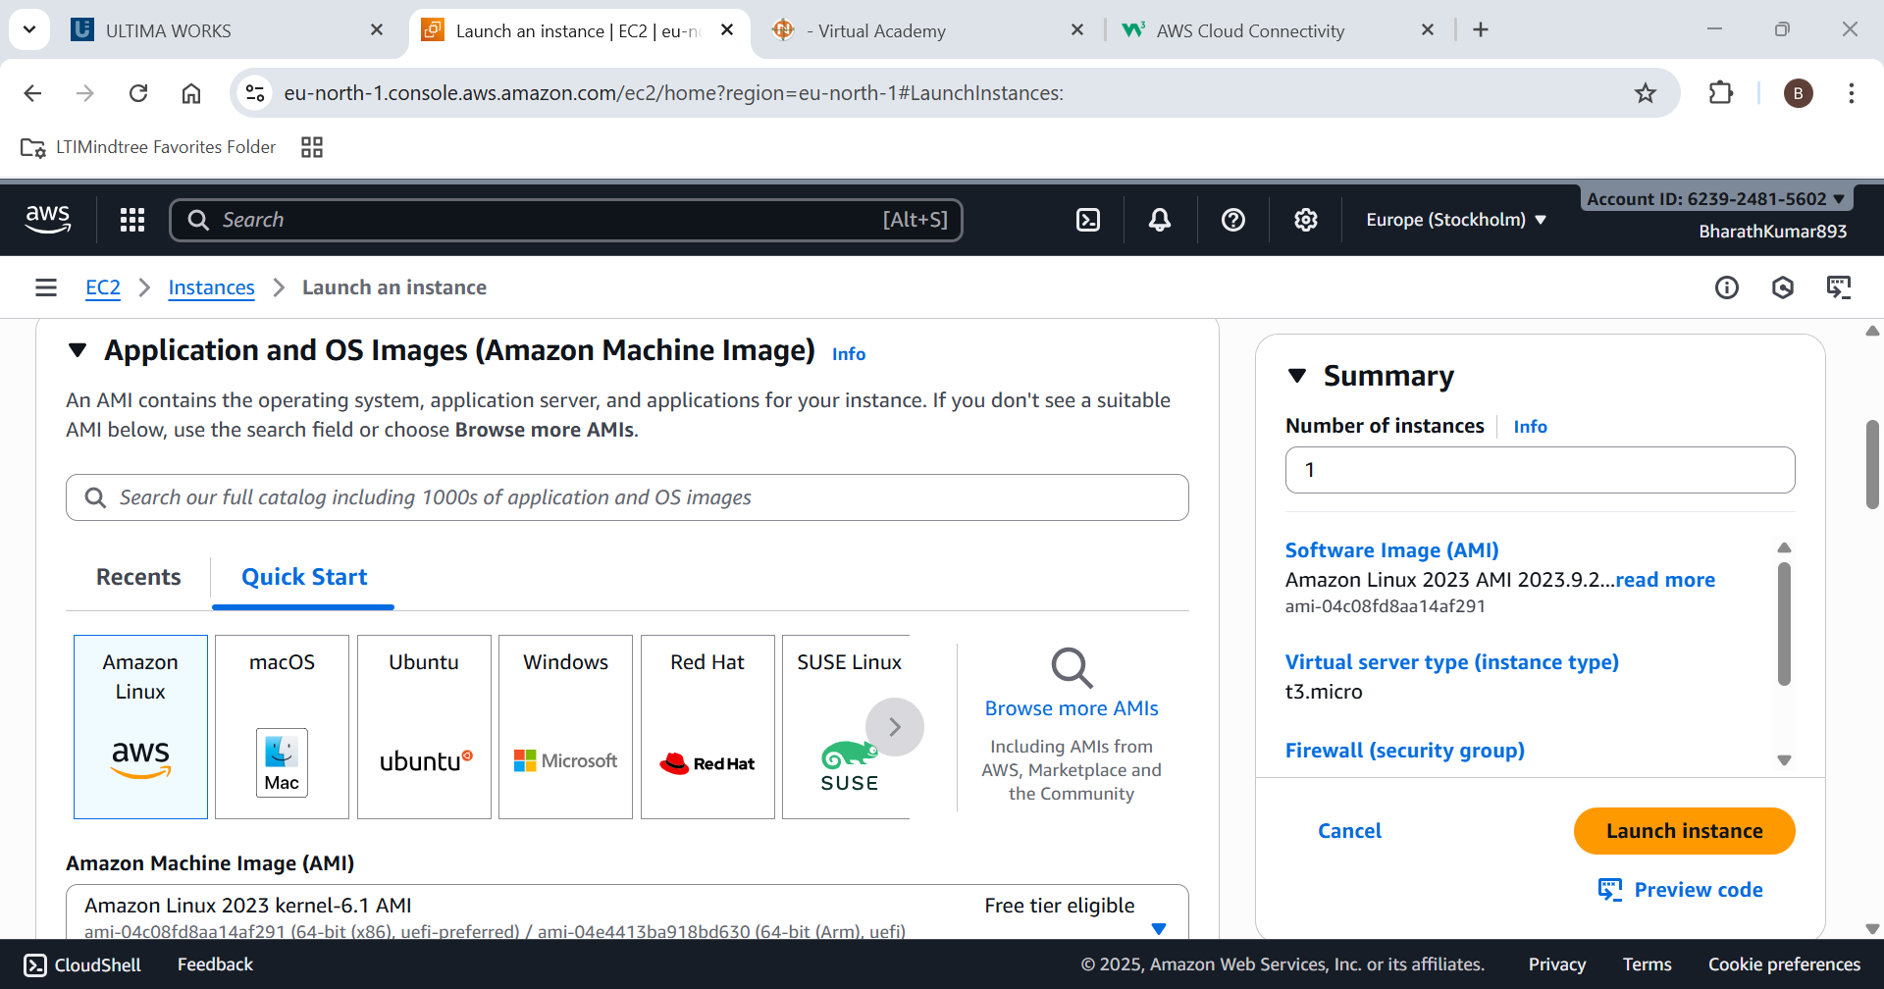

Step 4: Choose your instance type (here t as it is free tier)

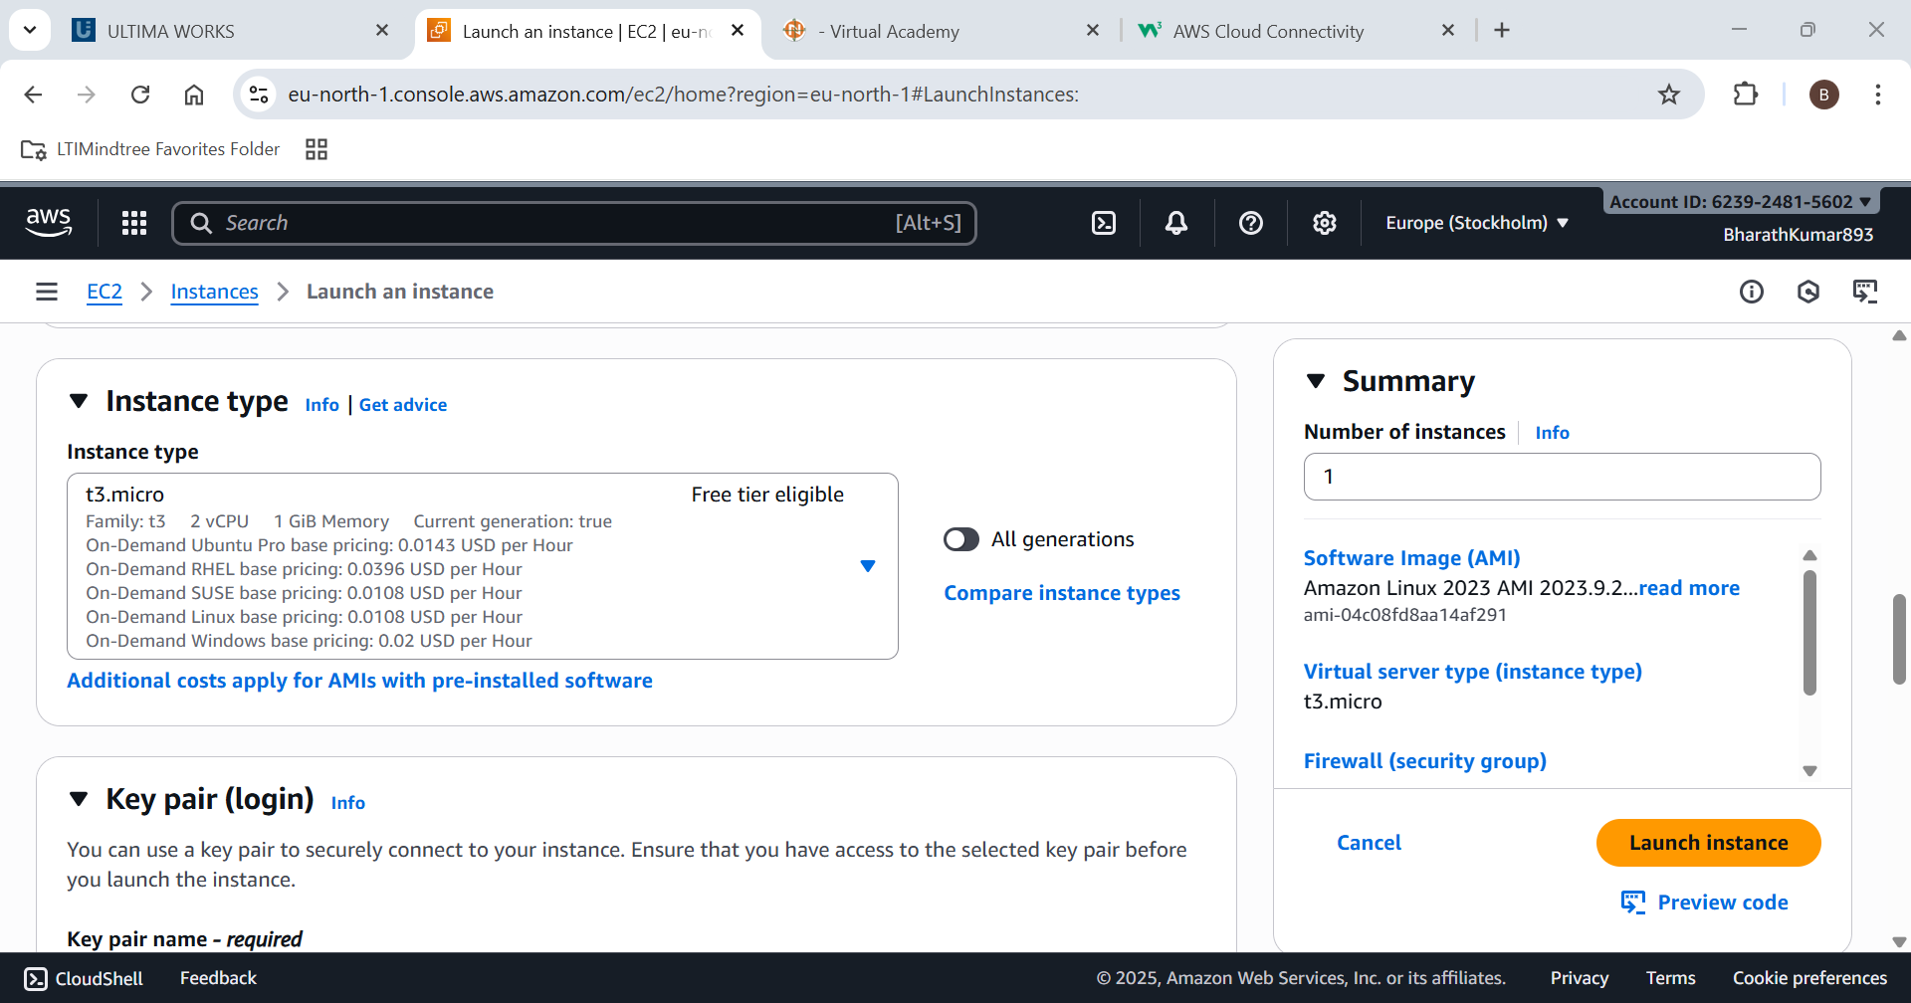

Step 5: Create a key value pair for later connections

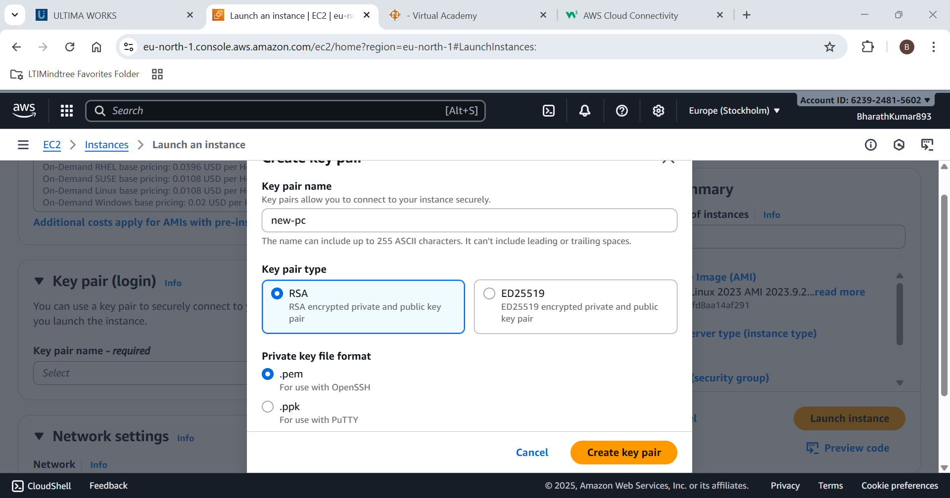

Step 6: Configure your network settings (Choose your VPC,Subnet and enable auto ip assign)

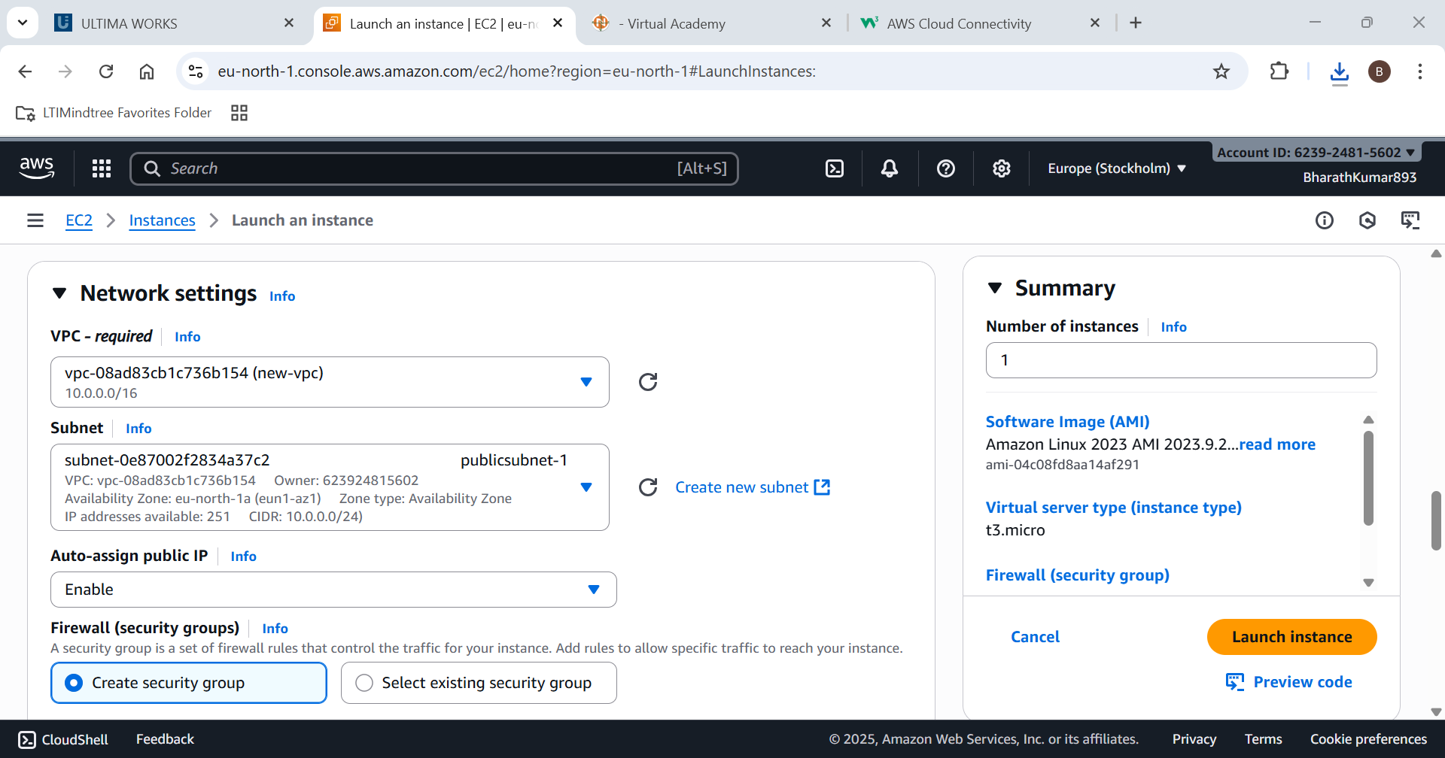

Step 7:Configure security group rules (Add http)

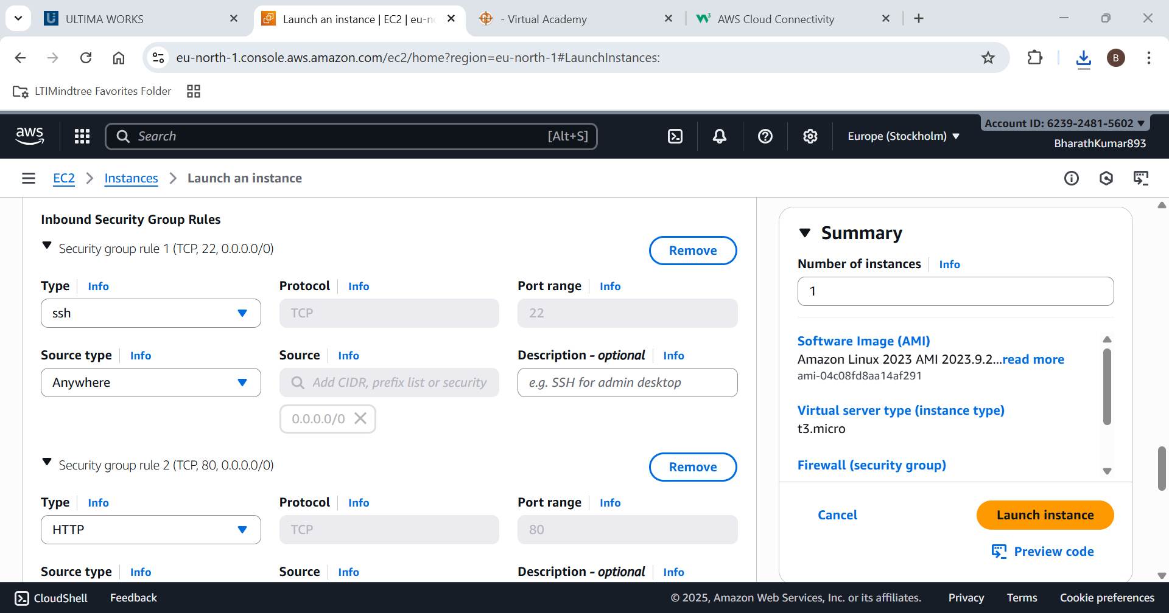

Our new EC2 instance is created

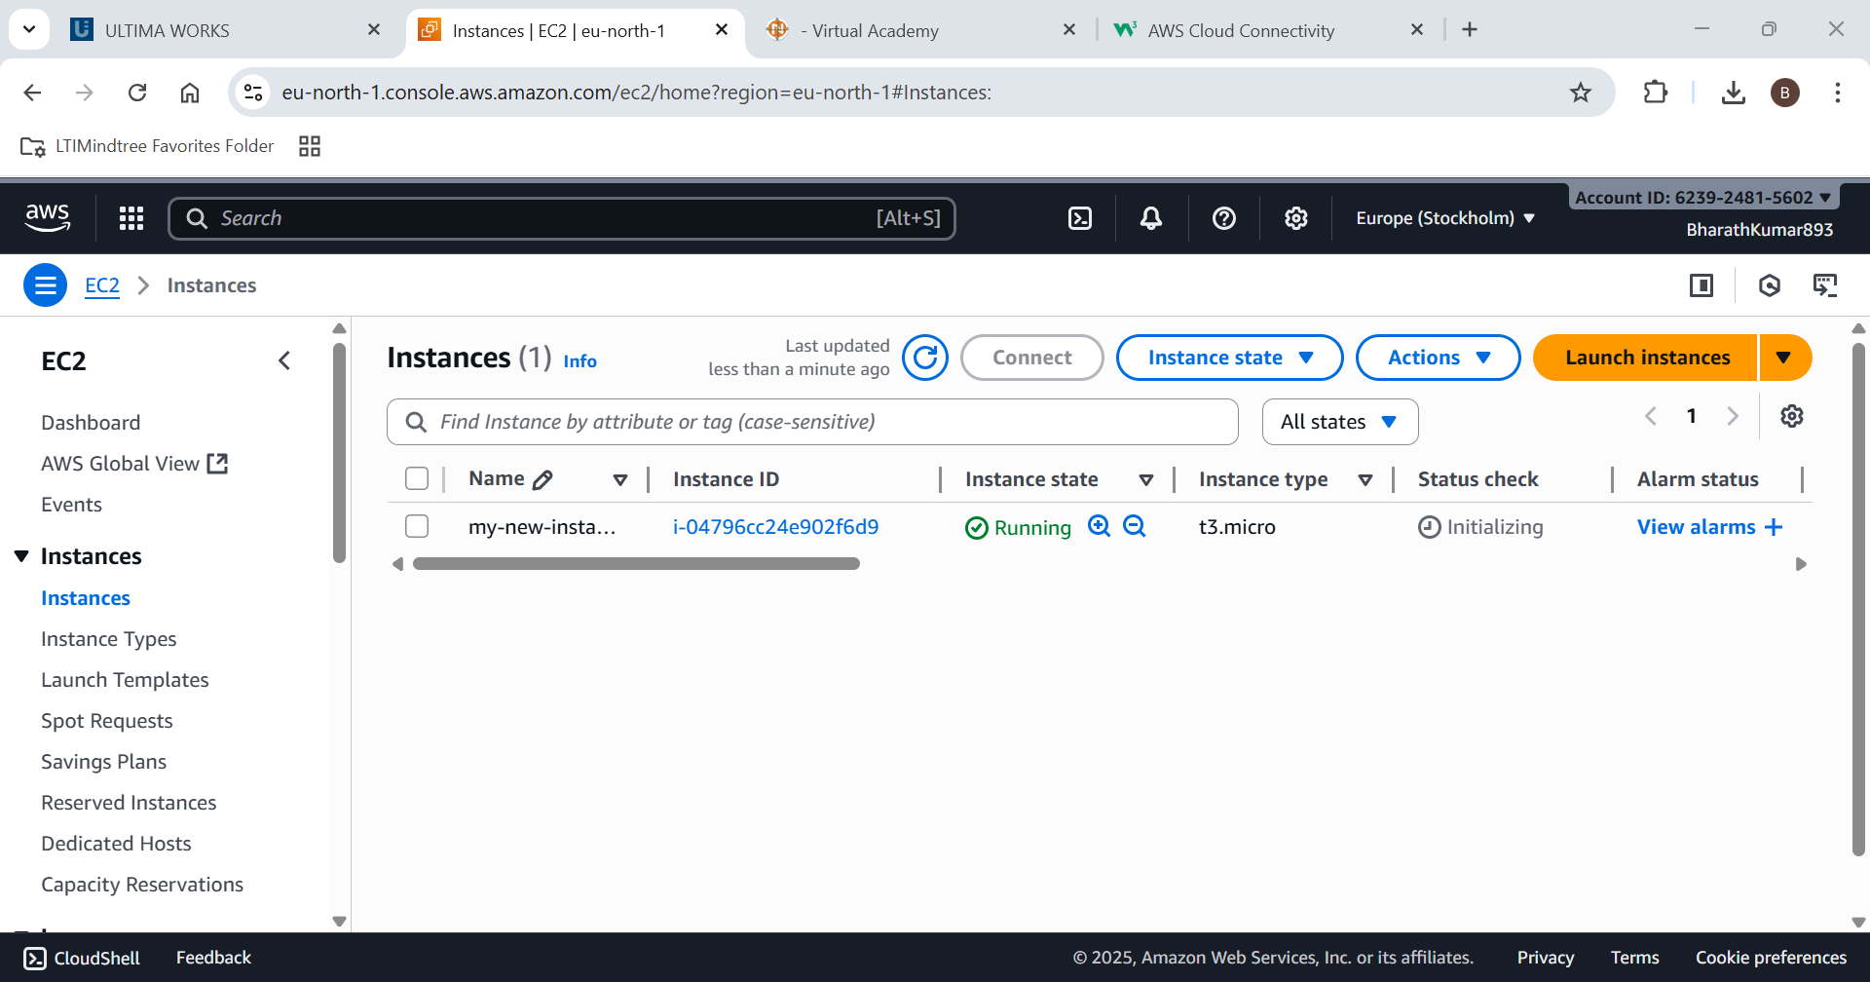

Step 8: Connect to your instance

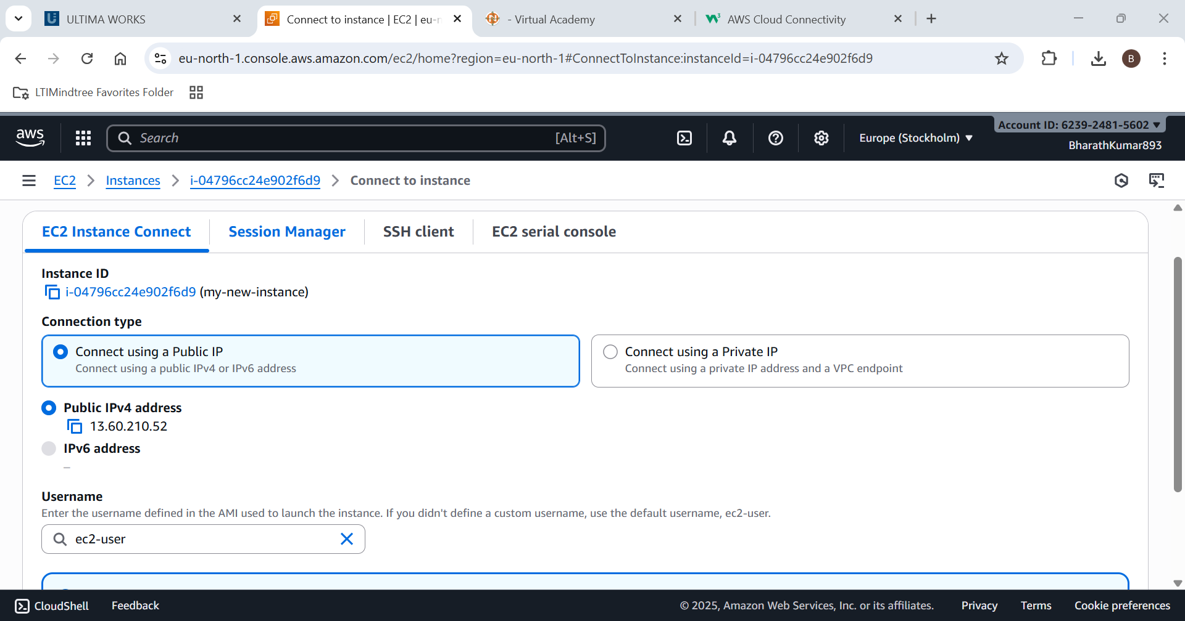

Step 9:Try to Connect it to the internet

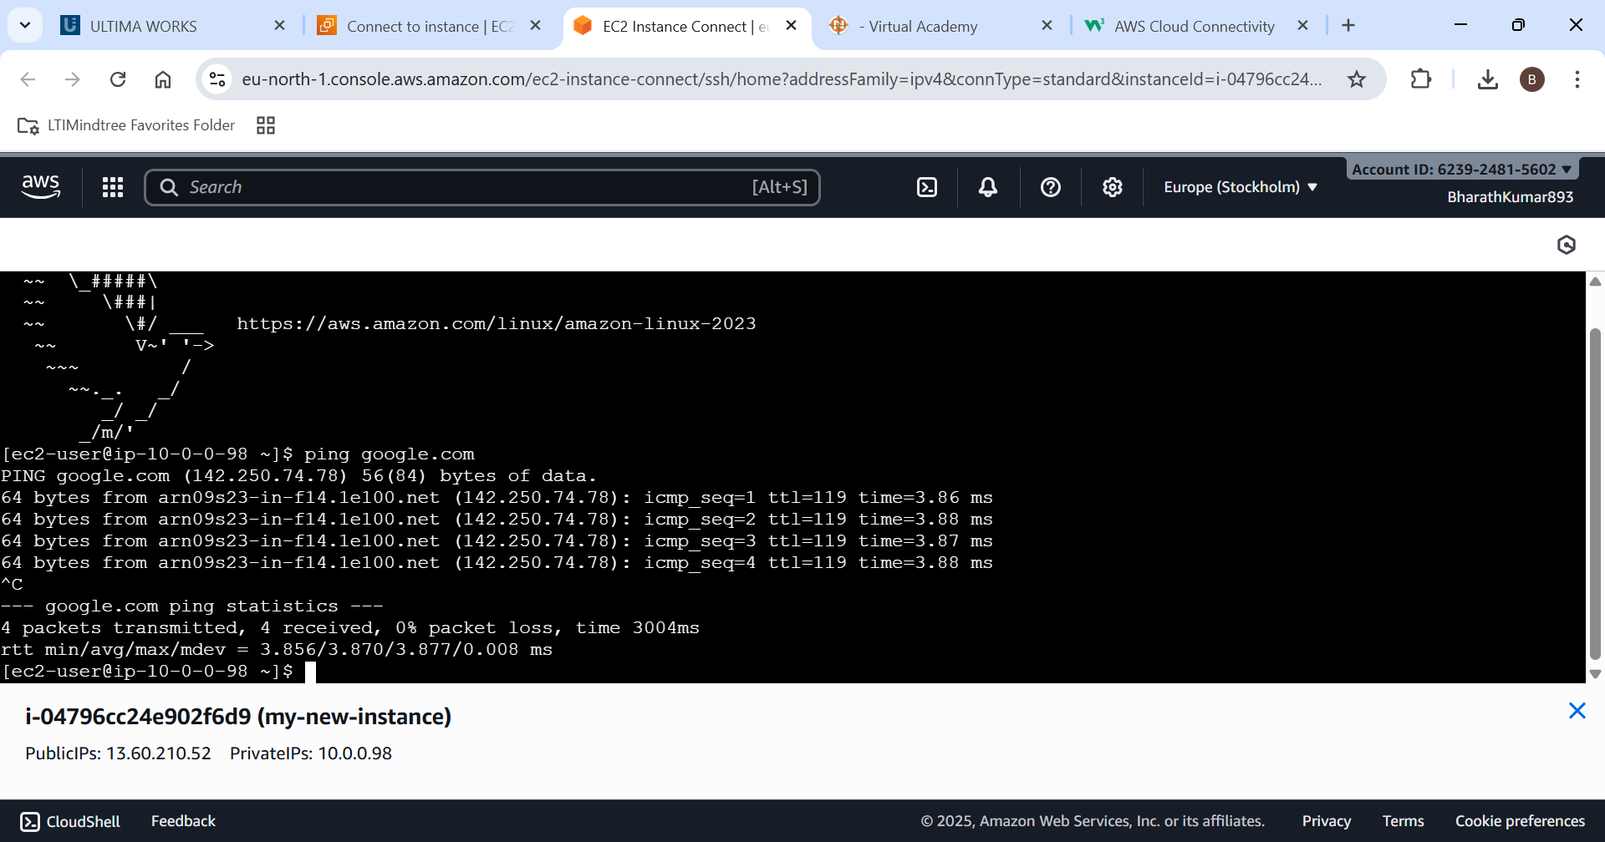

An EC2 instance is created and is done successfully.

1. Create an S3 bucket, upload a file, and make it publicly accessible.

Step 1: Open S3 bucket service

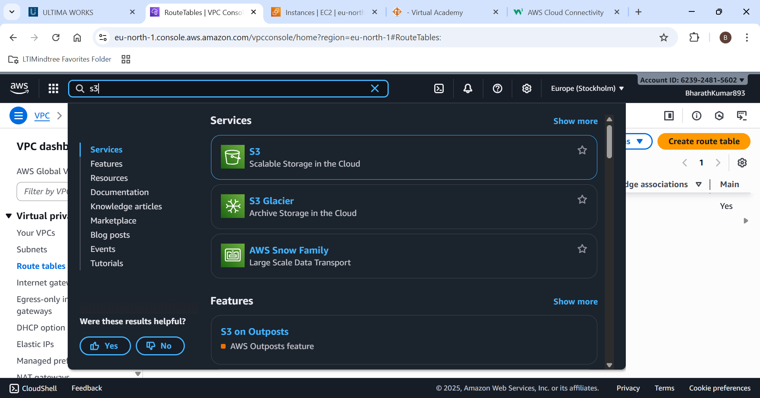

Step 2:Create a bucket service and give it a name.

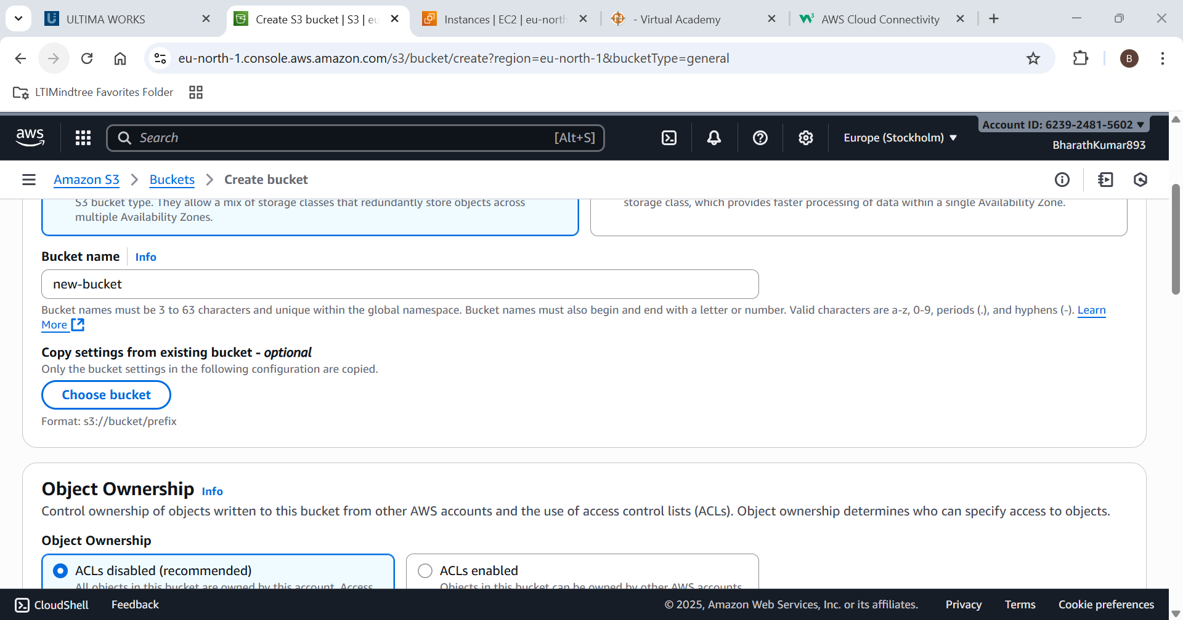

Step 3: Enable ACL

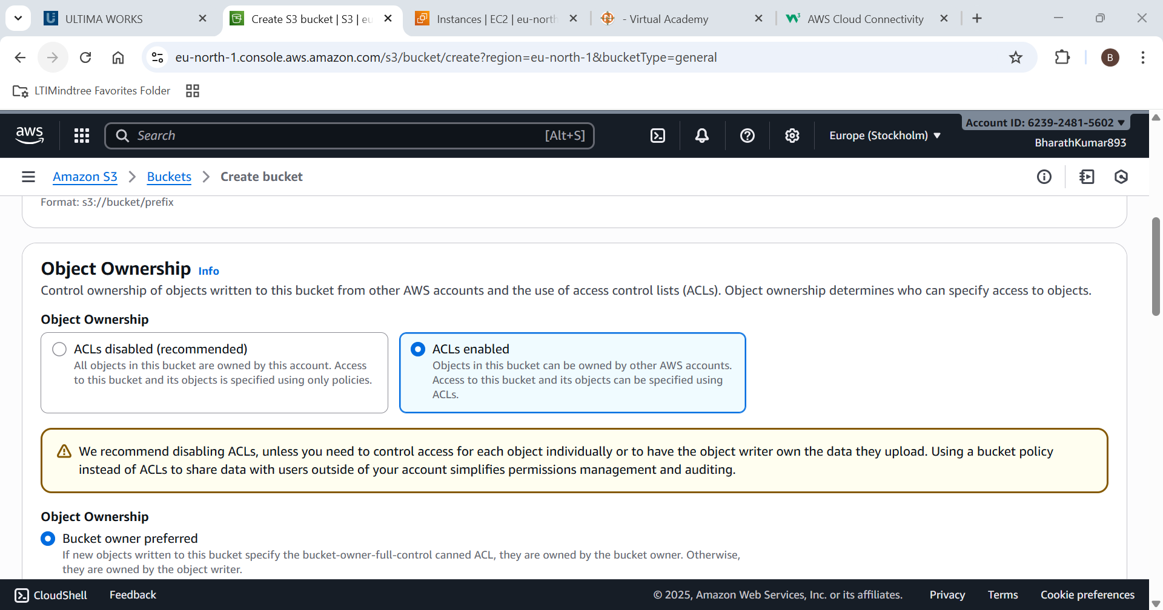

Step 4: Disable the blocked public access settings

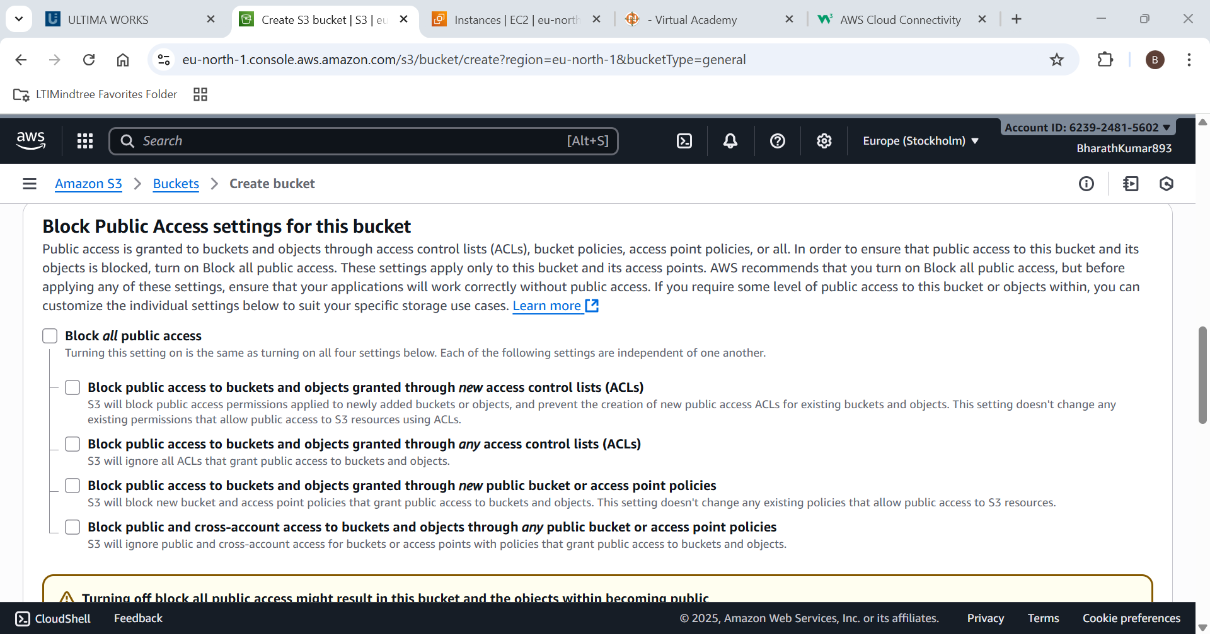

A bucket is created

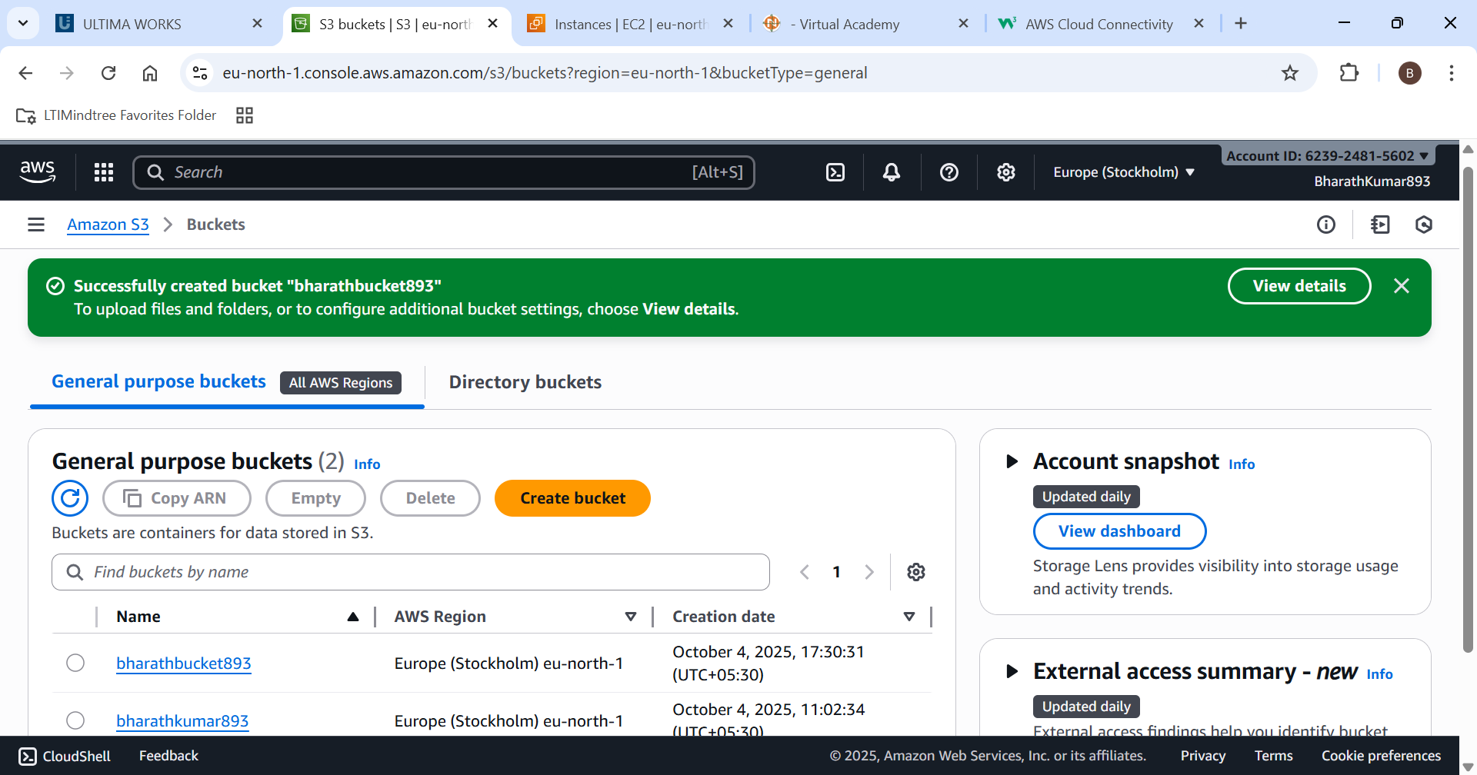

Step 5: Upload a file in S3 bucket.

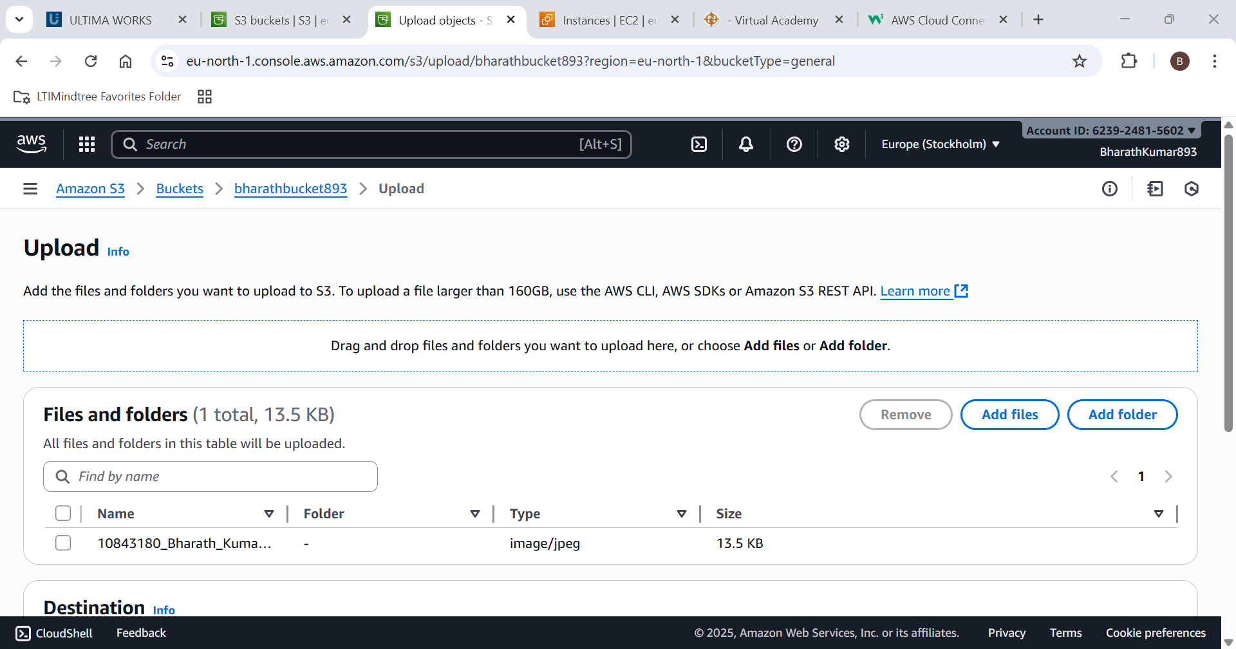

Step 6: Generate a S3 bucket policy

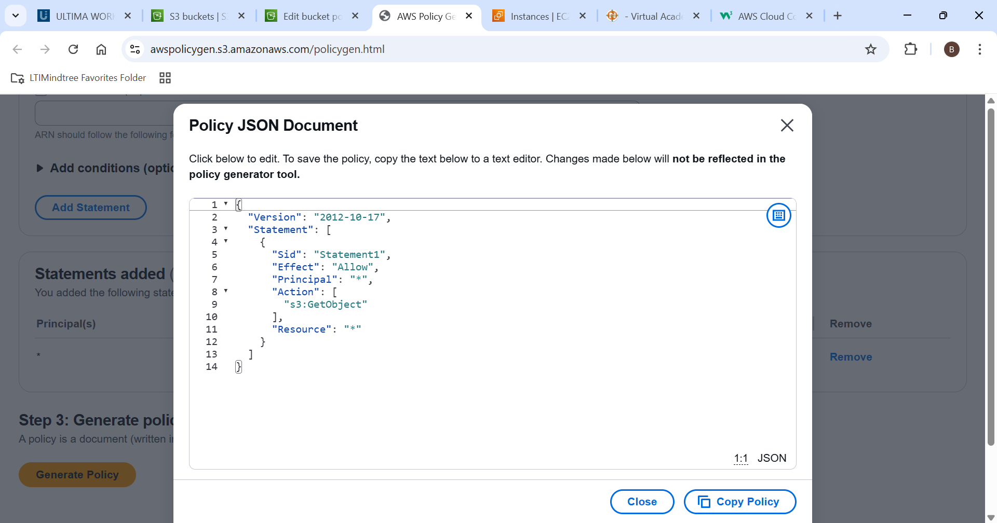

Step 7: Add your arn number in the resource for allowing access.

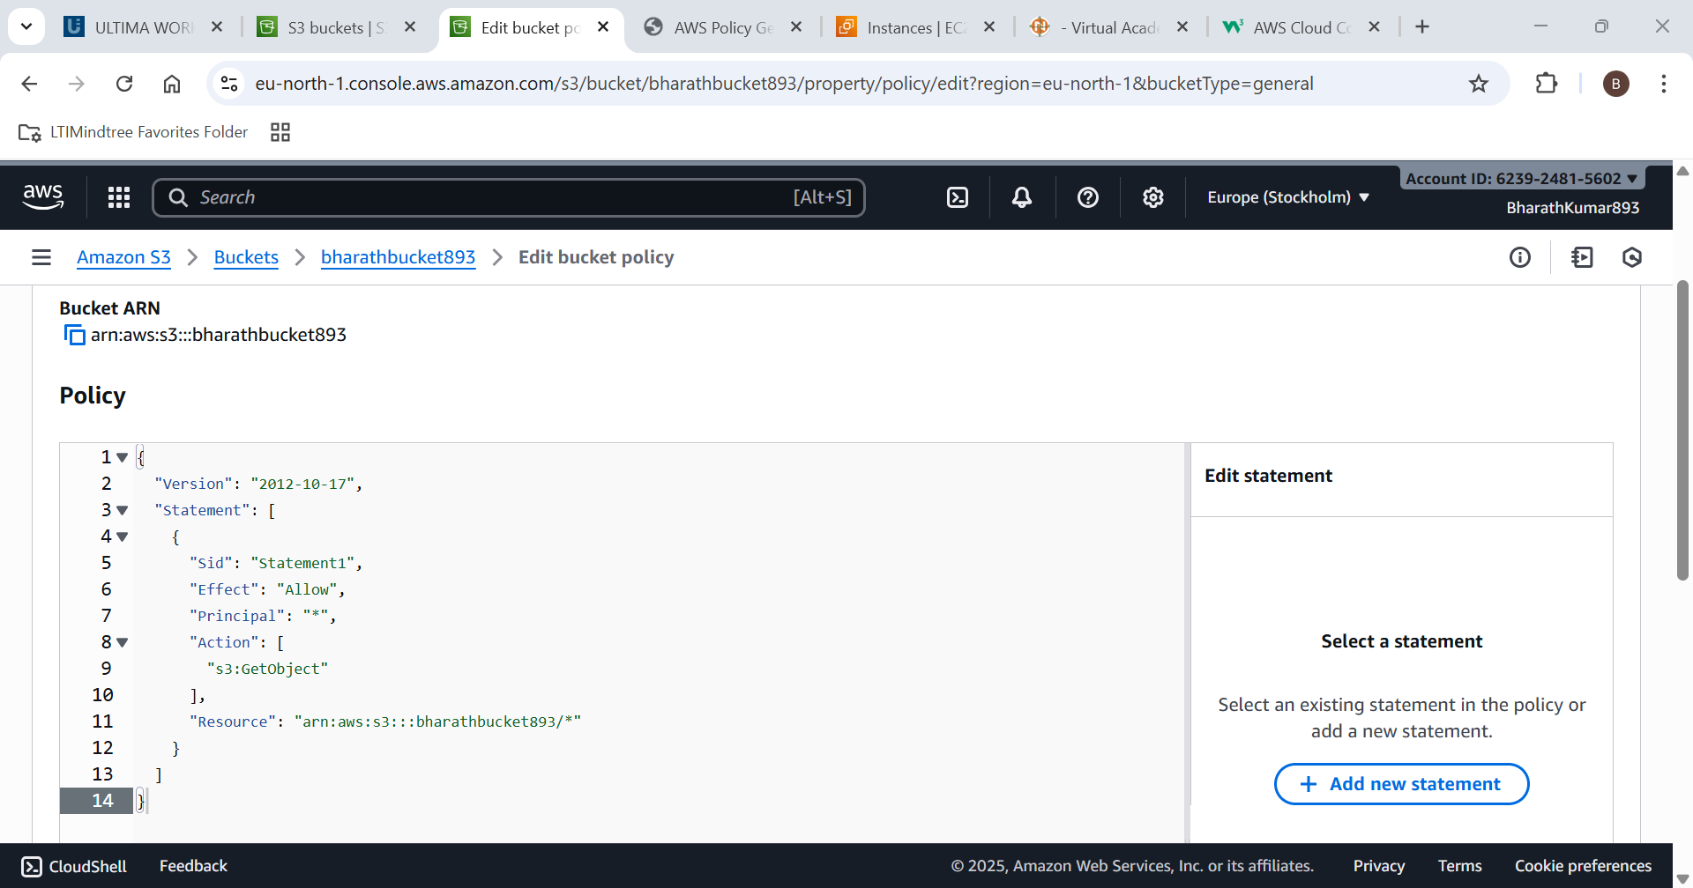

Now this displays the details about the resource

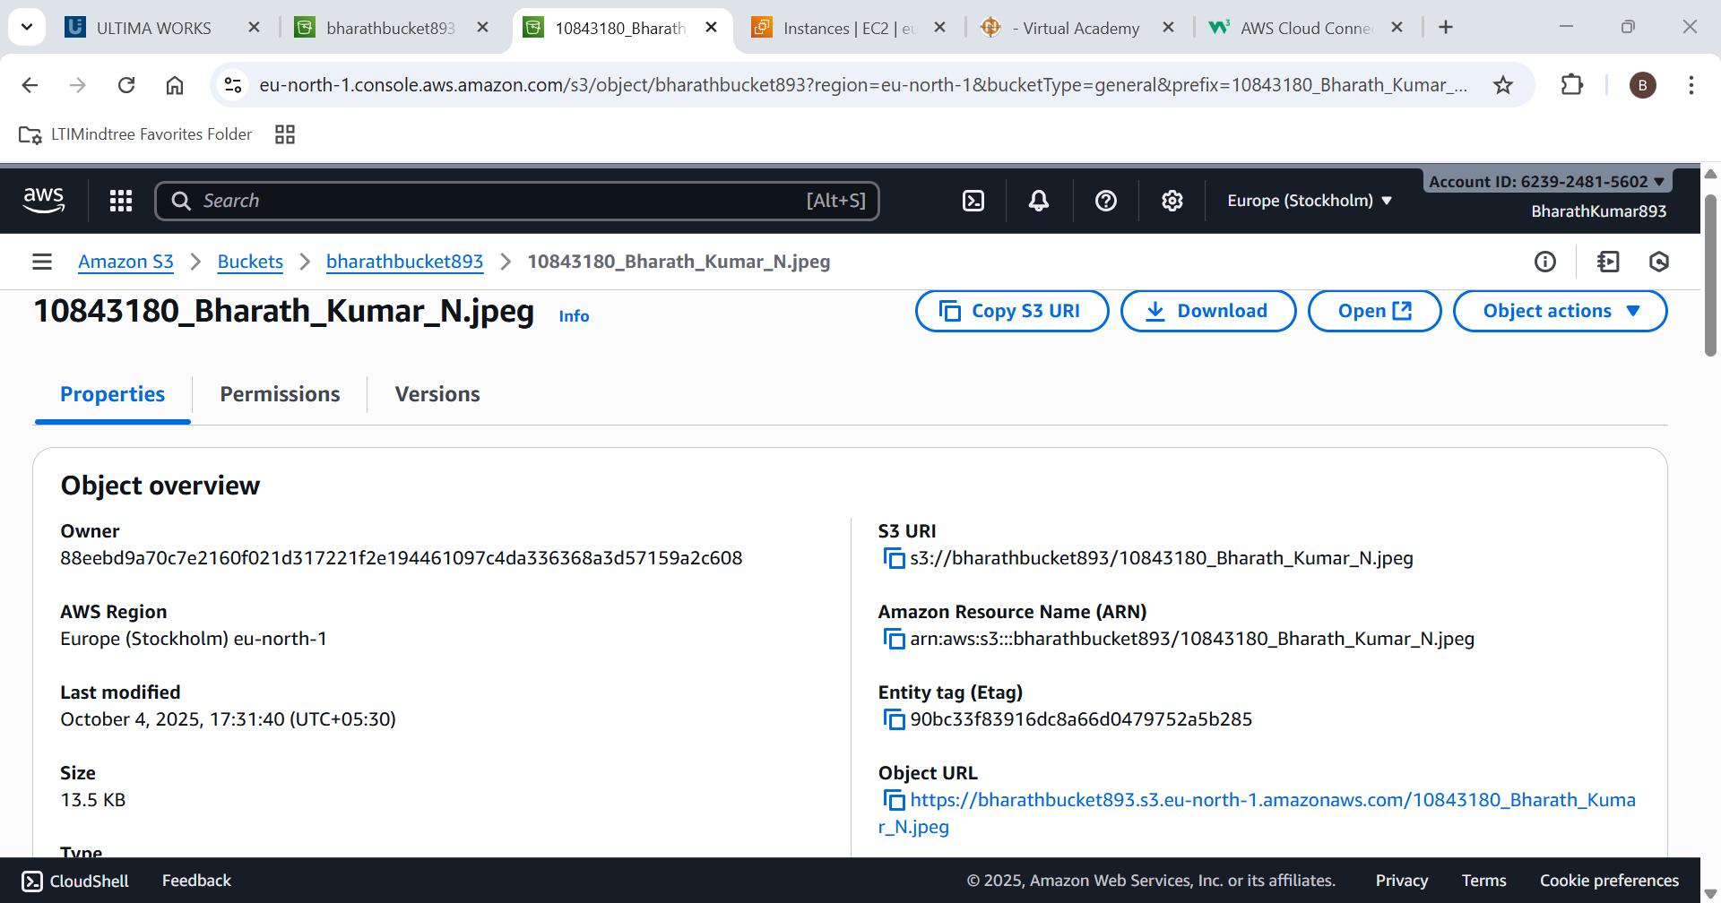

Now open the object URL

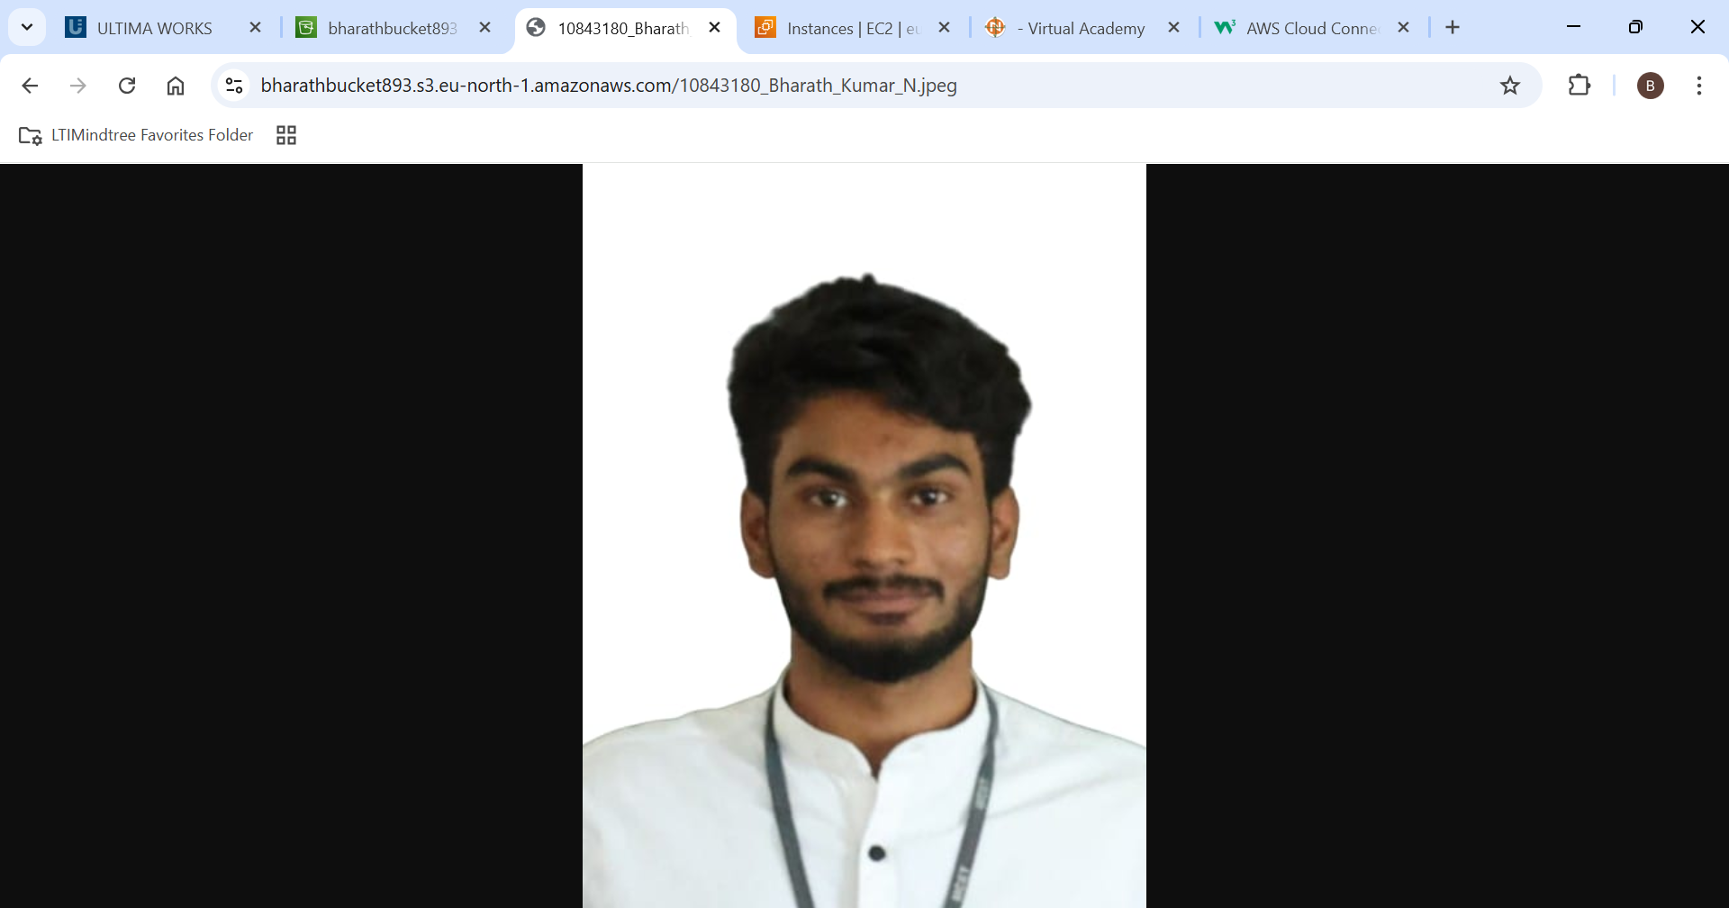

If the Object is displayed in the URL , the experiment was a success.

1. Configure a VPC with 2 public and 2 private subnets.

Step 1: Open VPC service

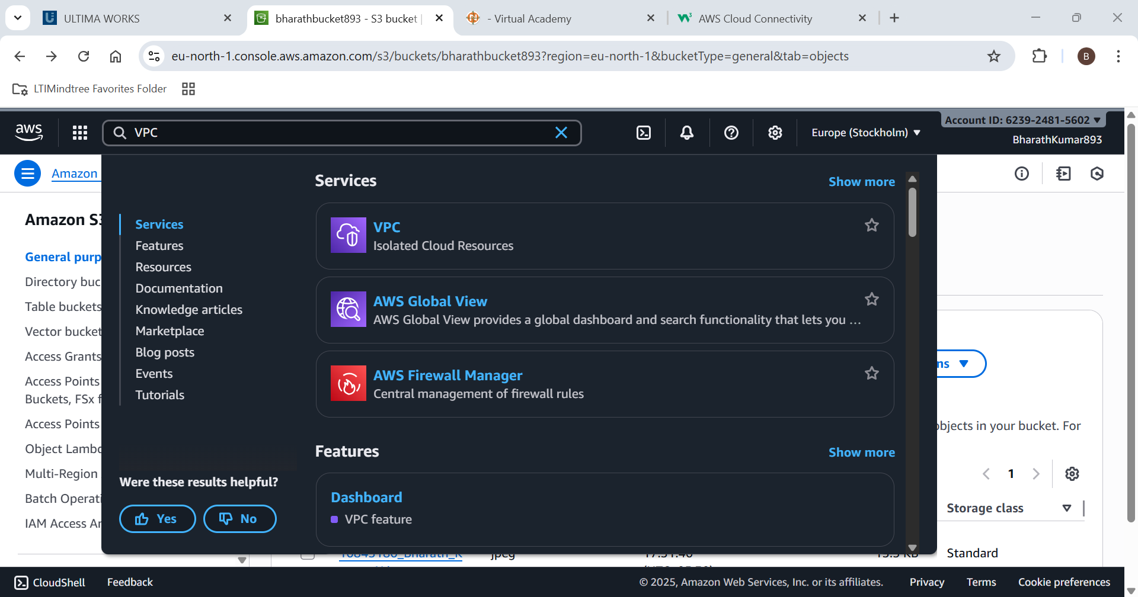

Give VPC name,CIDR range

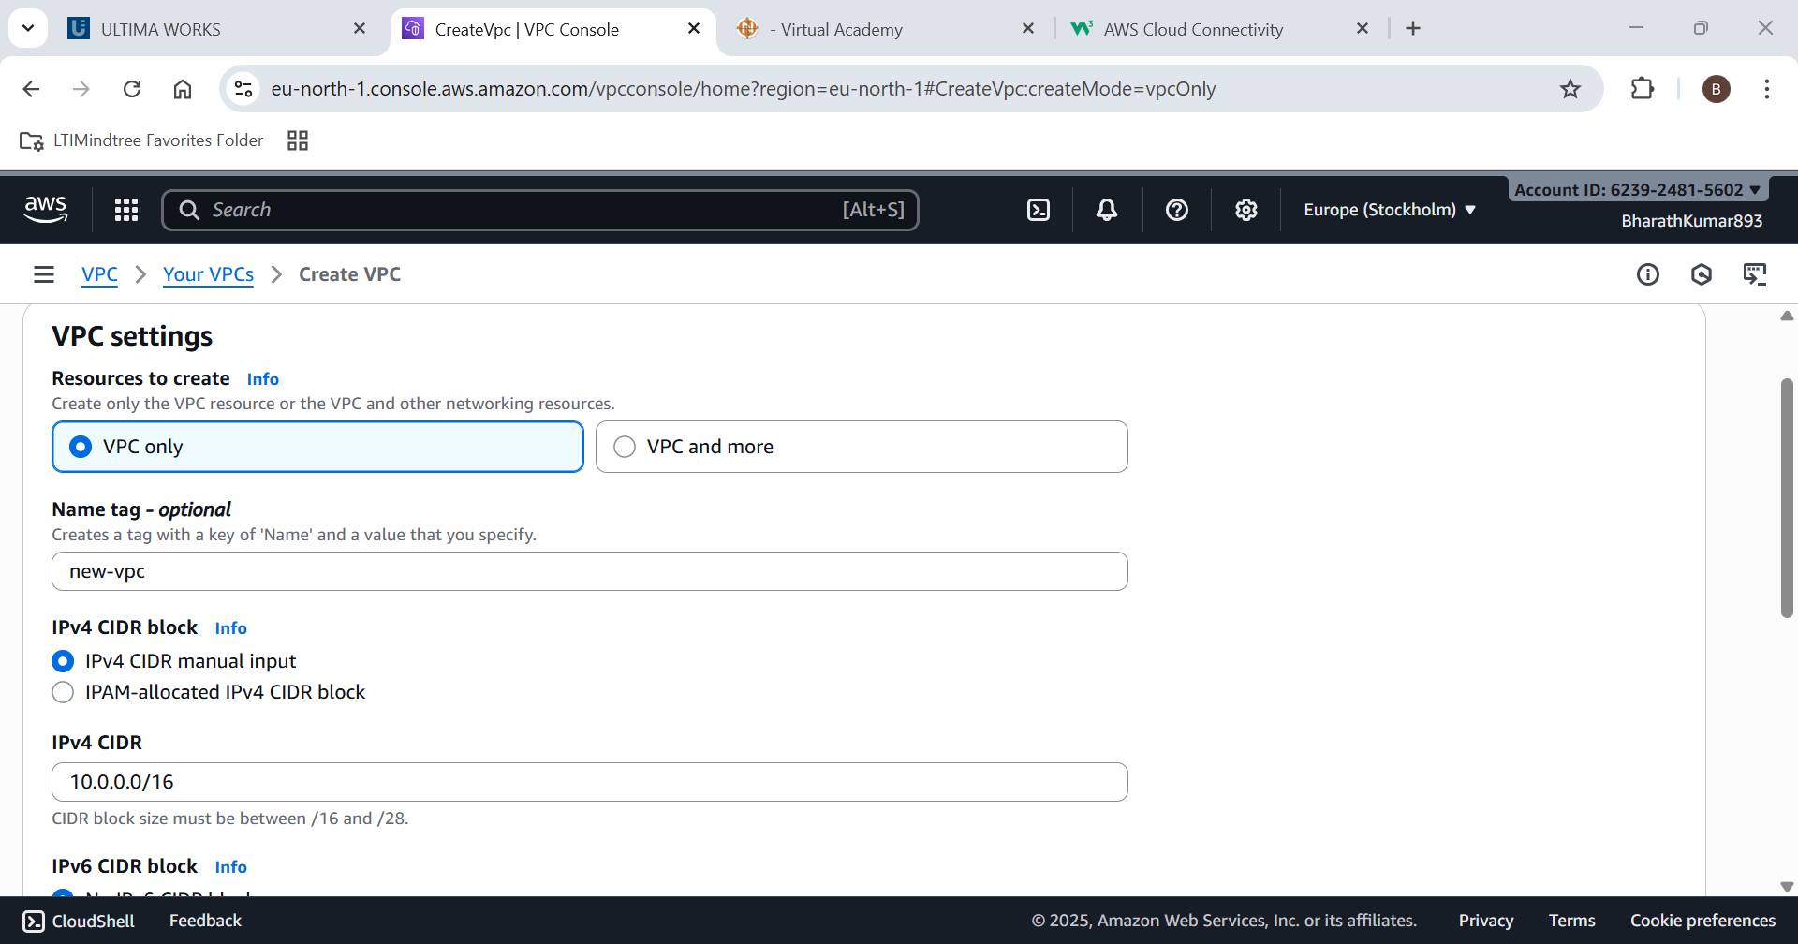

VPC Created Successfully

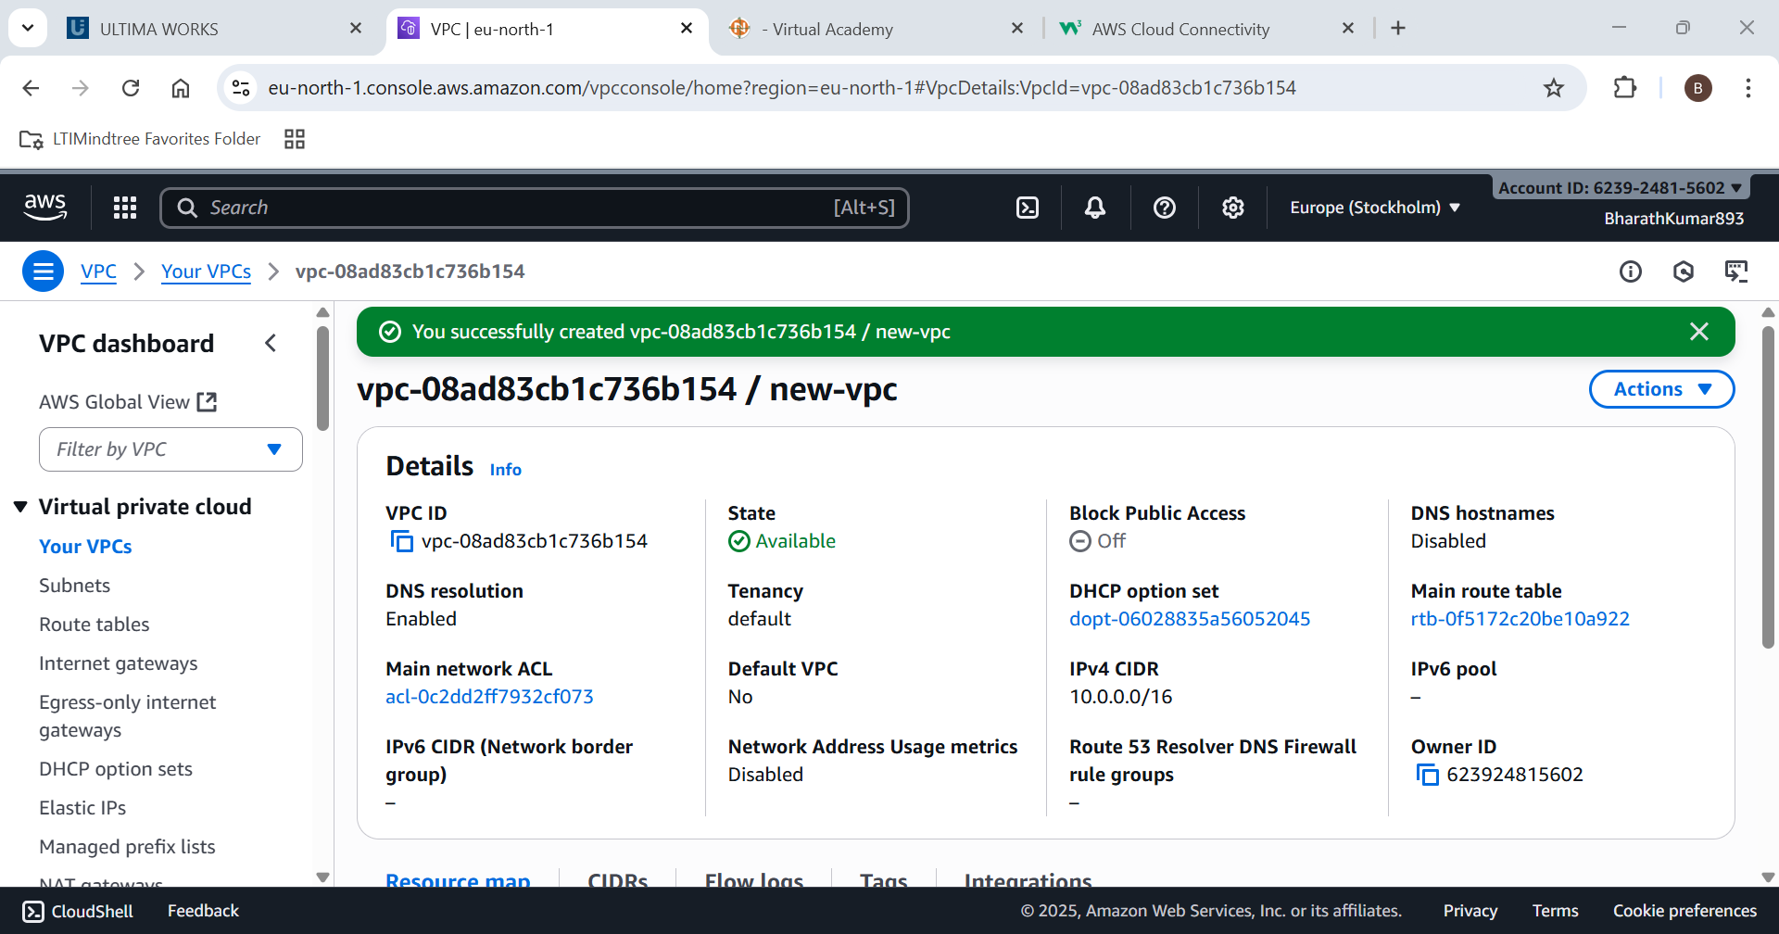

Go to subnets and add your VPC to it

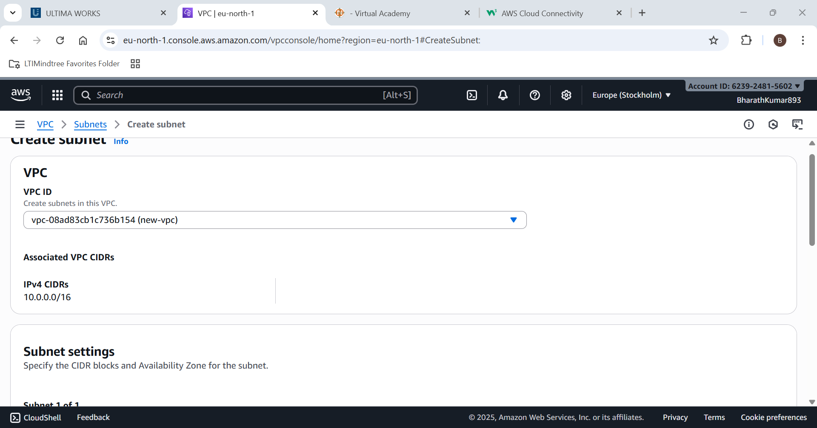

Create 2 public and 2 private subnet to it

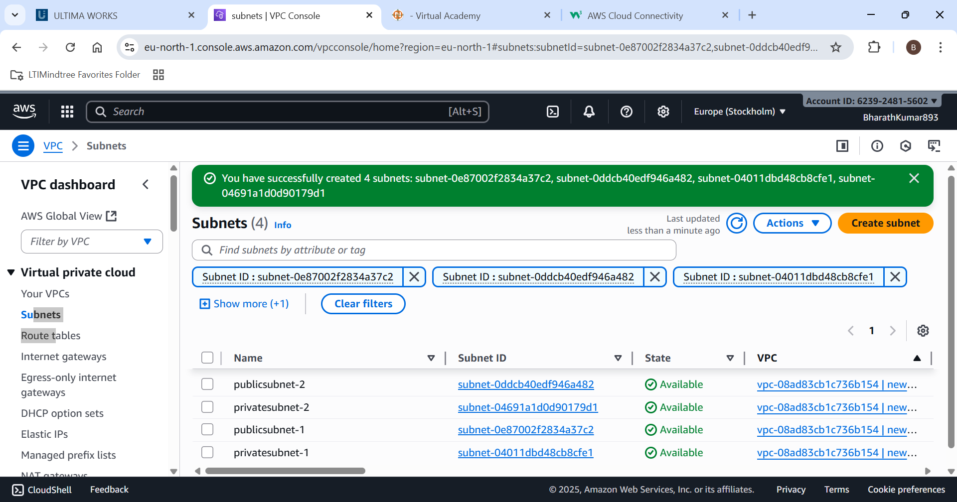

Here the resource map displays the subnets and its associations

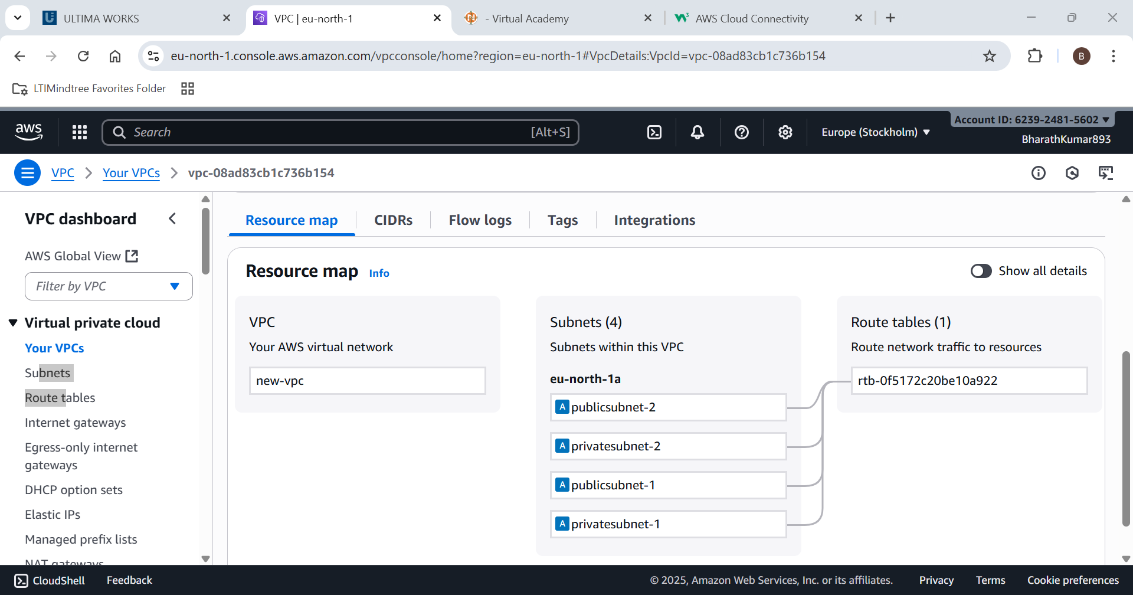

Hence a VPC with 2 public and 2 private subnet is created successfully.

1. Attach an Internet Gateway to a VPC and update the route table to enable internet access.

Step 1: We are using an already opened the VPC

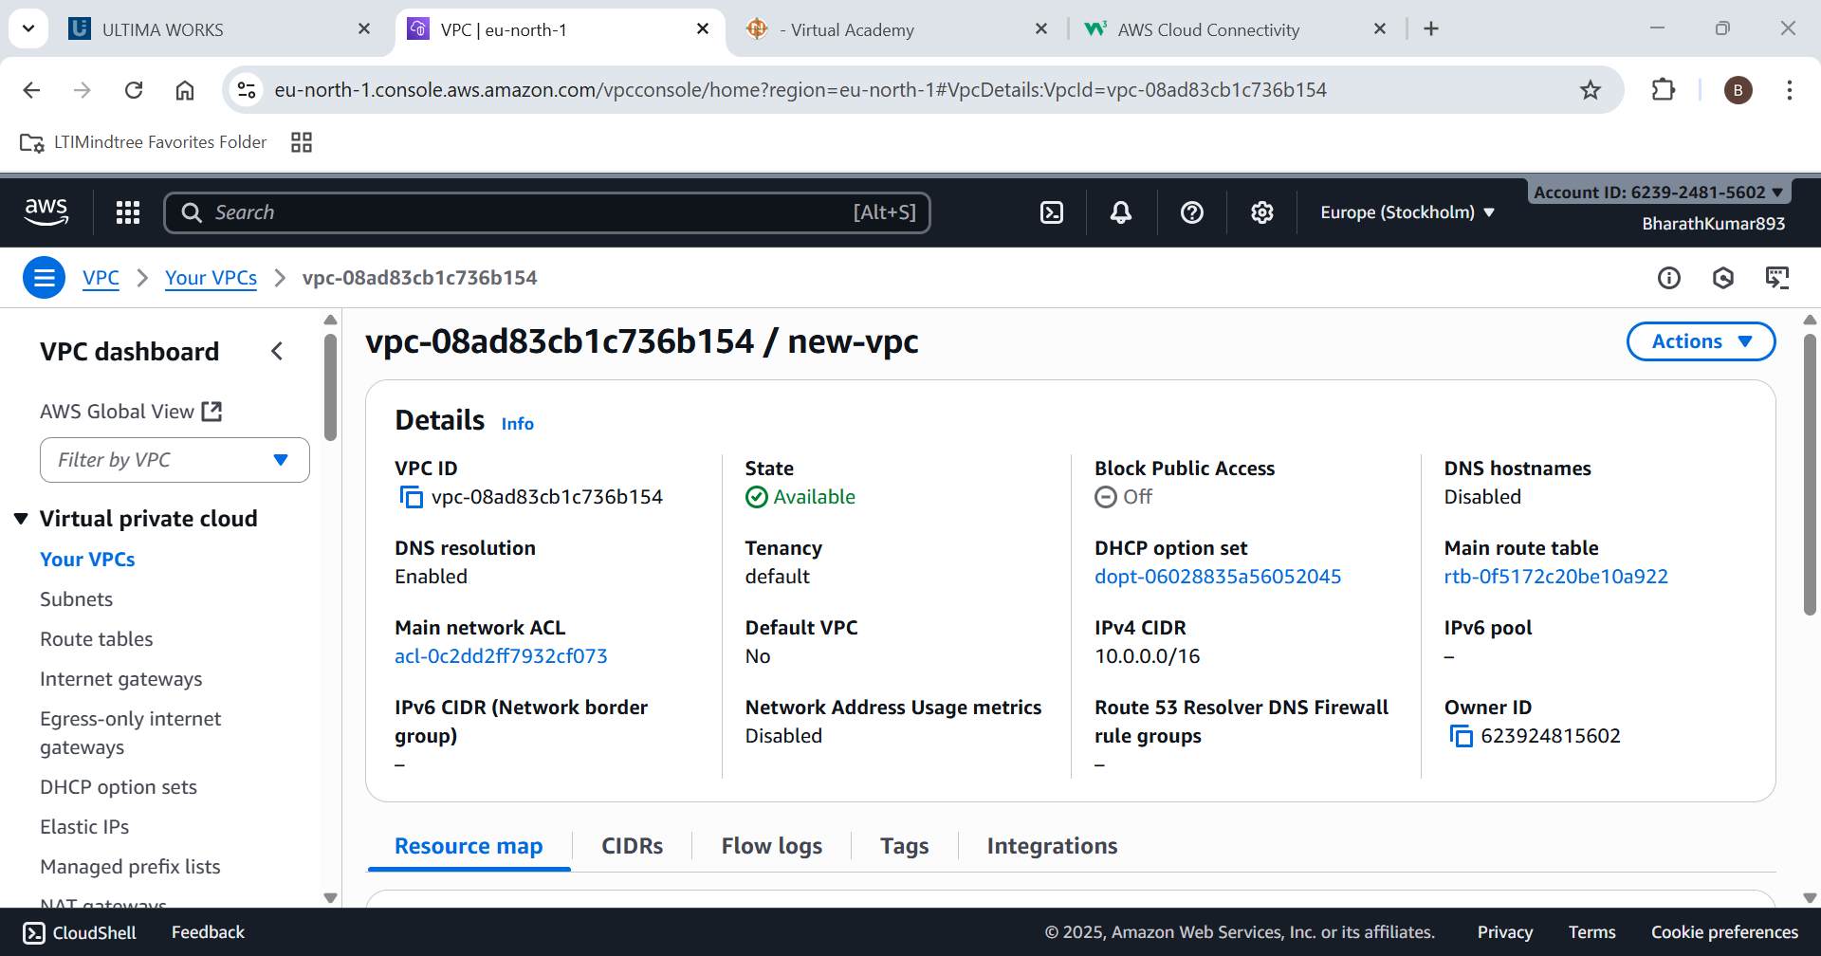

Create a new gateway

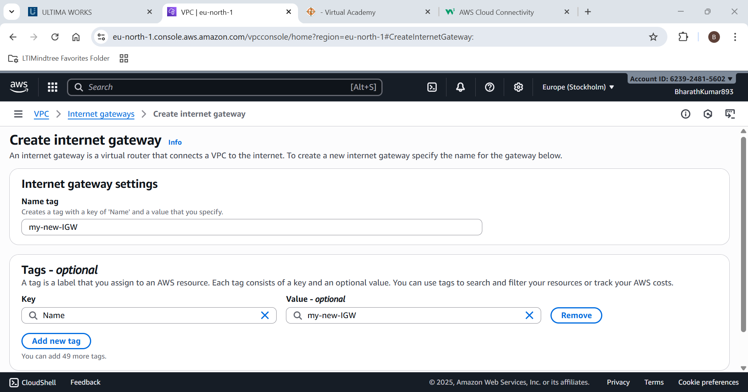

Attach it to the VPC

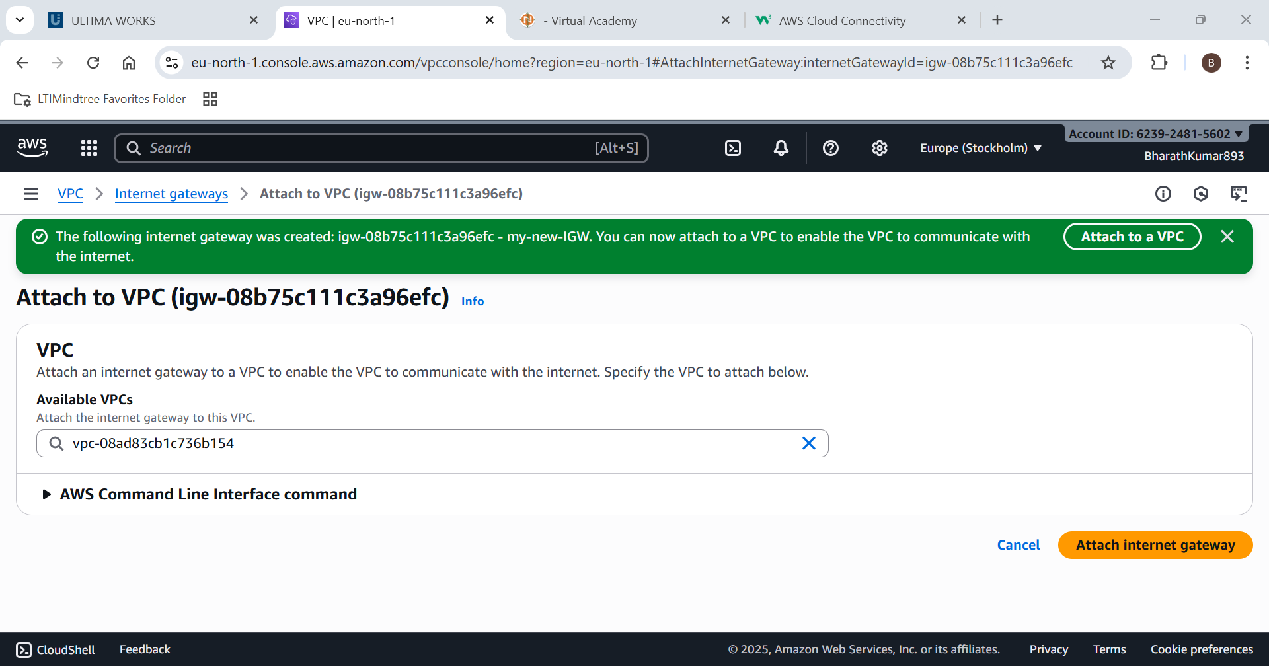

VPC is attached with the Internet gateway

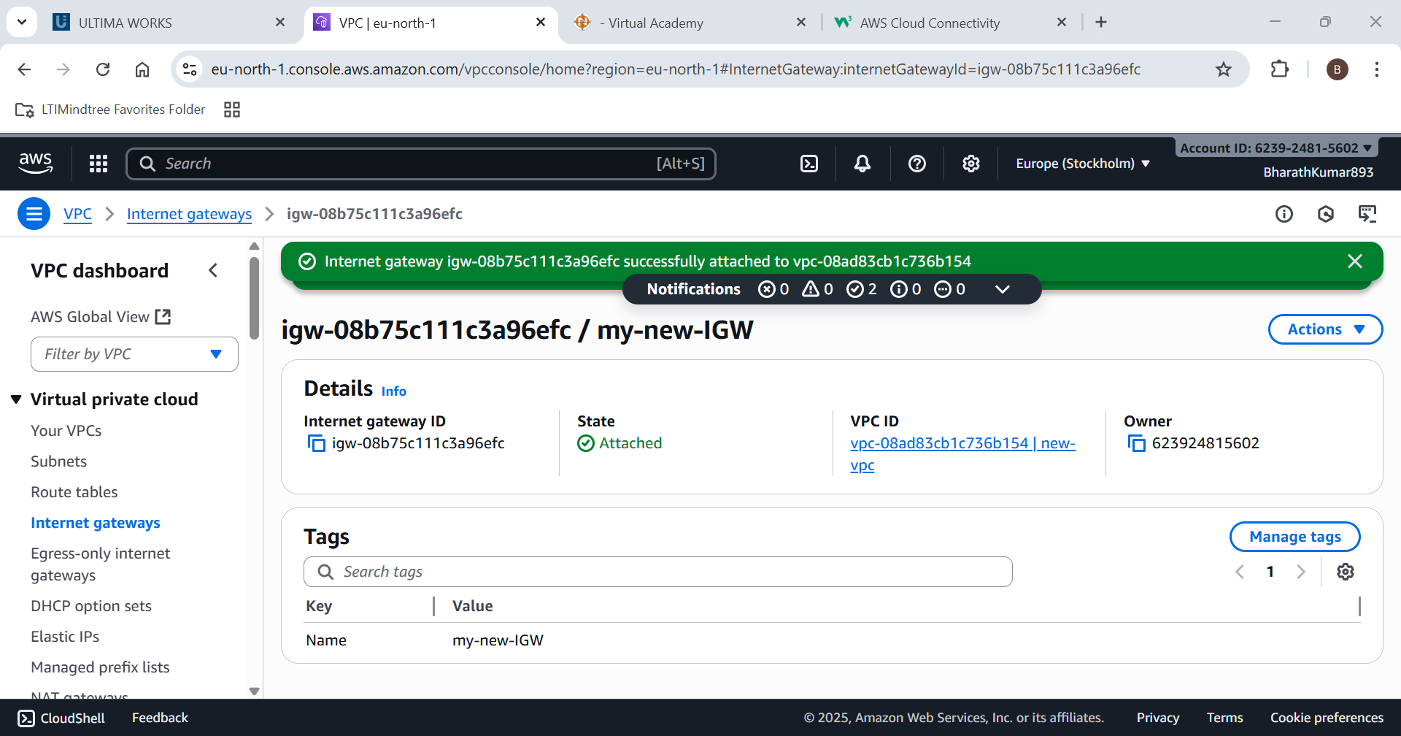

Now create a routing table and configure it.

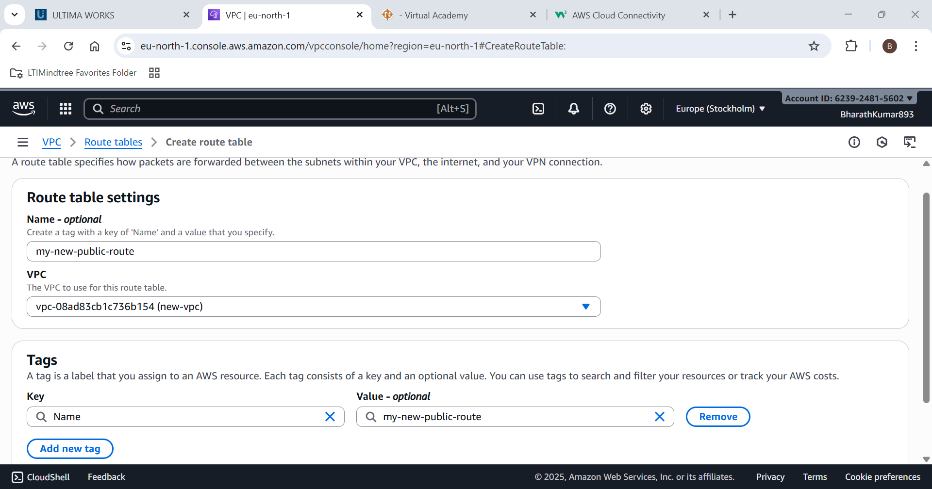

Add Internet gateway to the public subnet

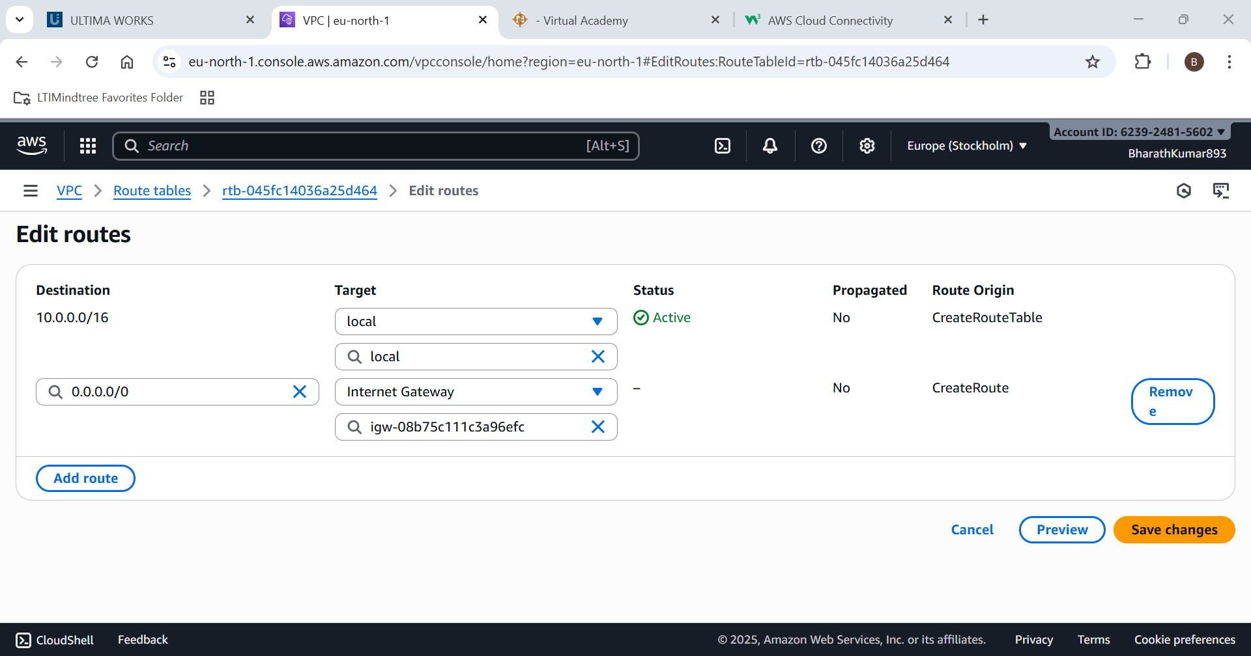

Create subnet associations for public subnet

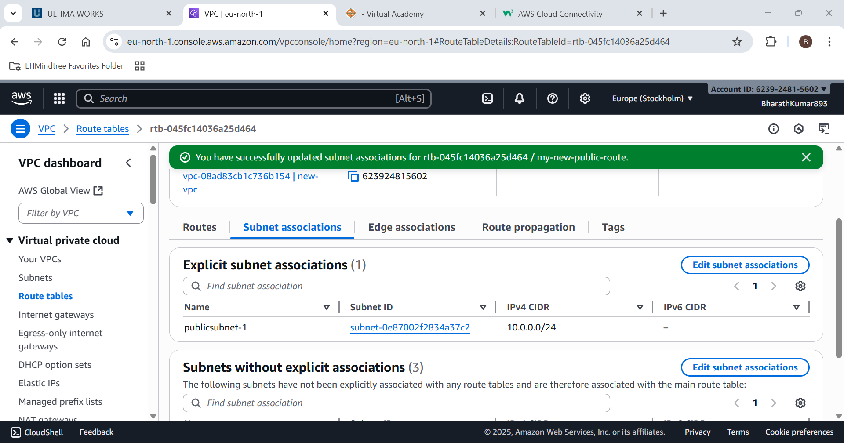

The Resource map shows the data

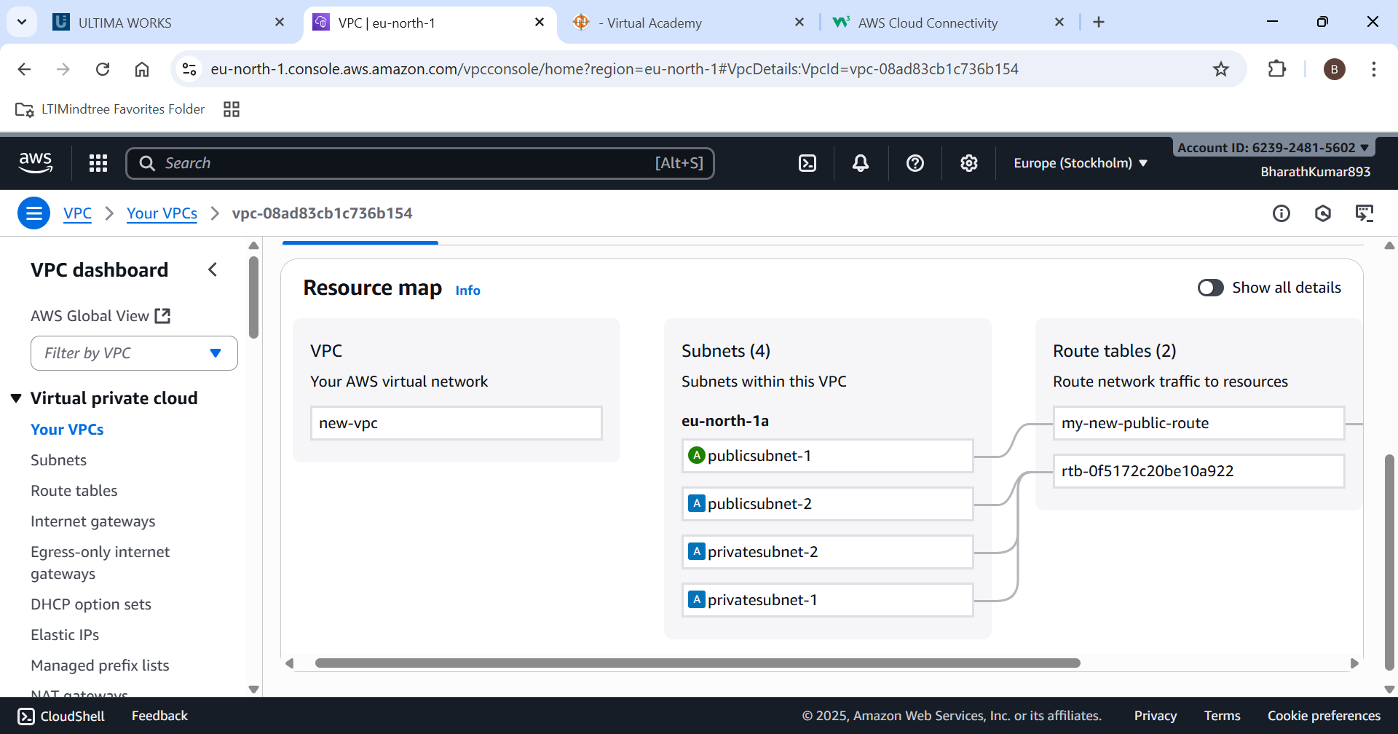

You can see the Internet gateway connected to it.

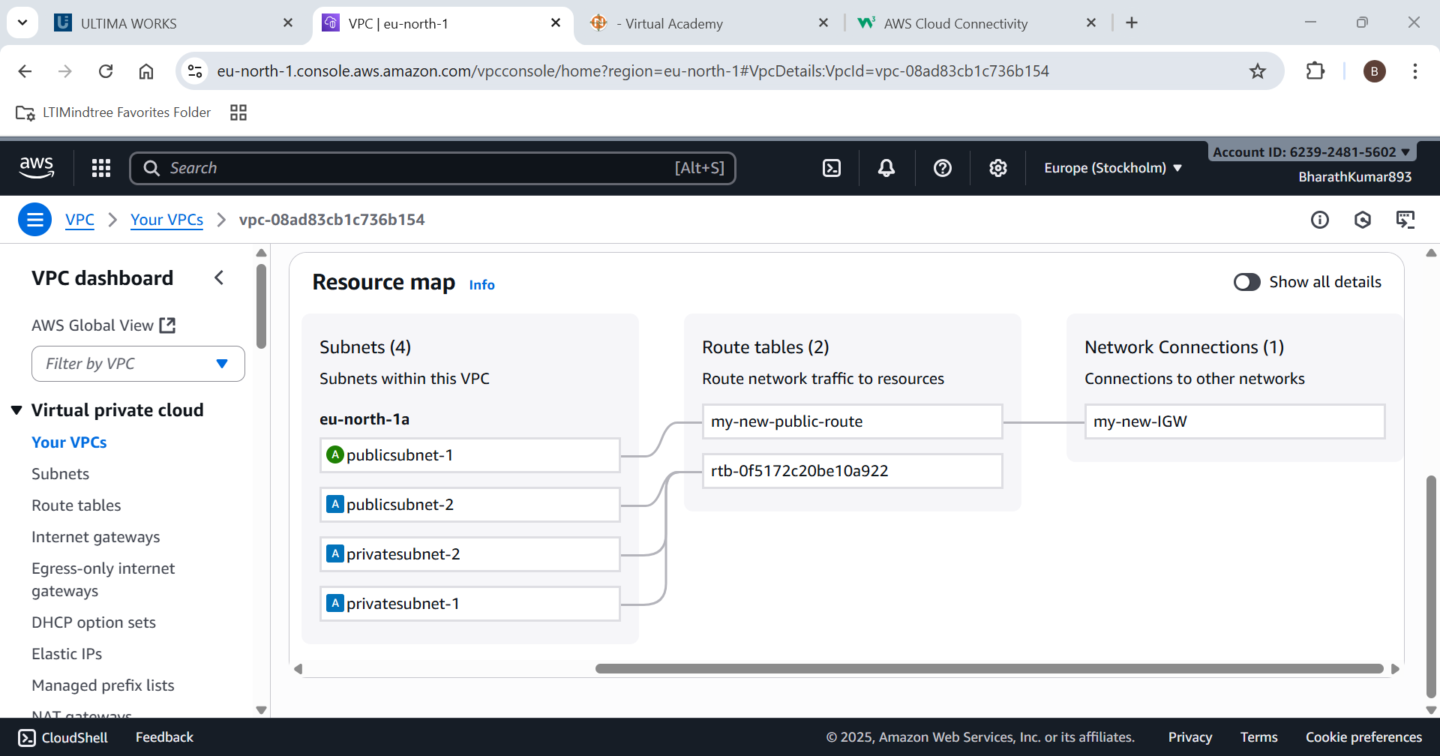

Try to use the internet in EC2 where the VPC is connected



1. Create a NAT Gateway in a public subnet and configure private subnet instances to access the internet.

Step 1:Create a private EC2 instance

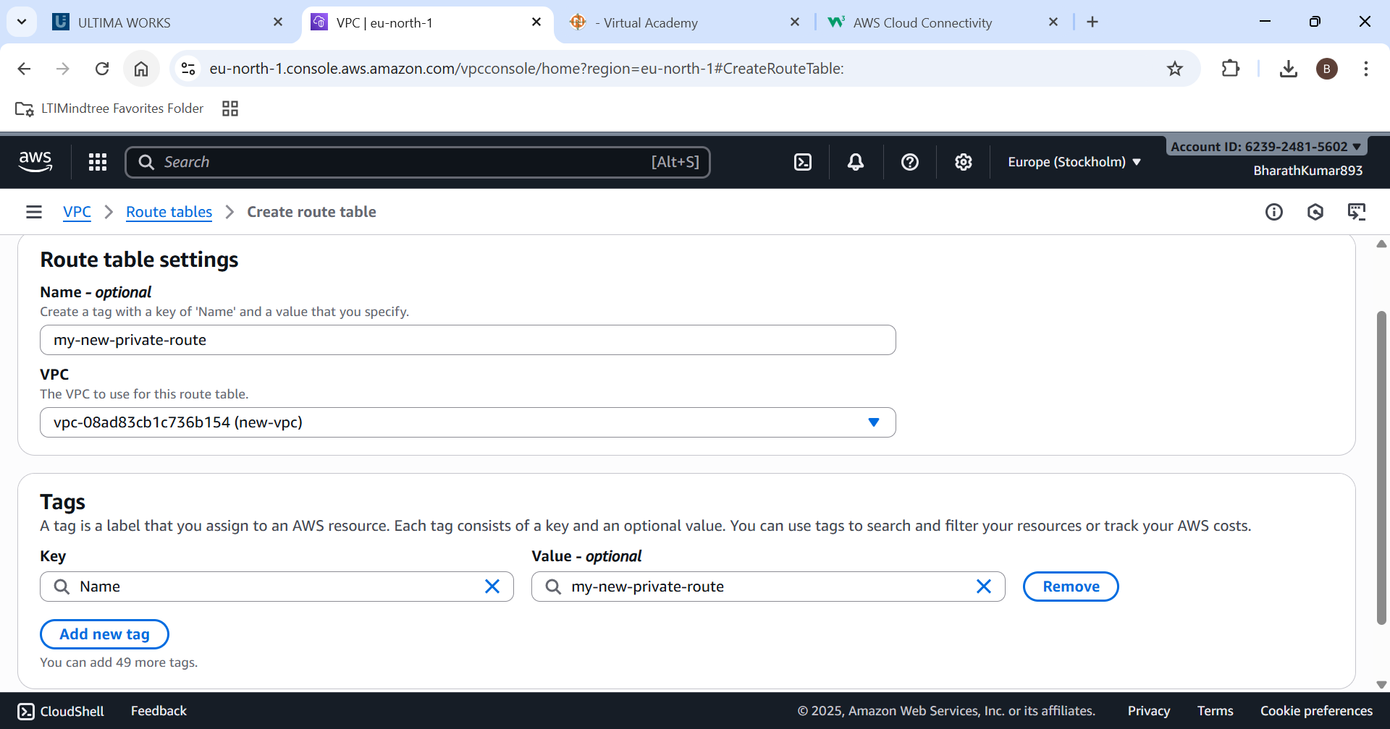

Configure the subnet associations

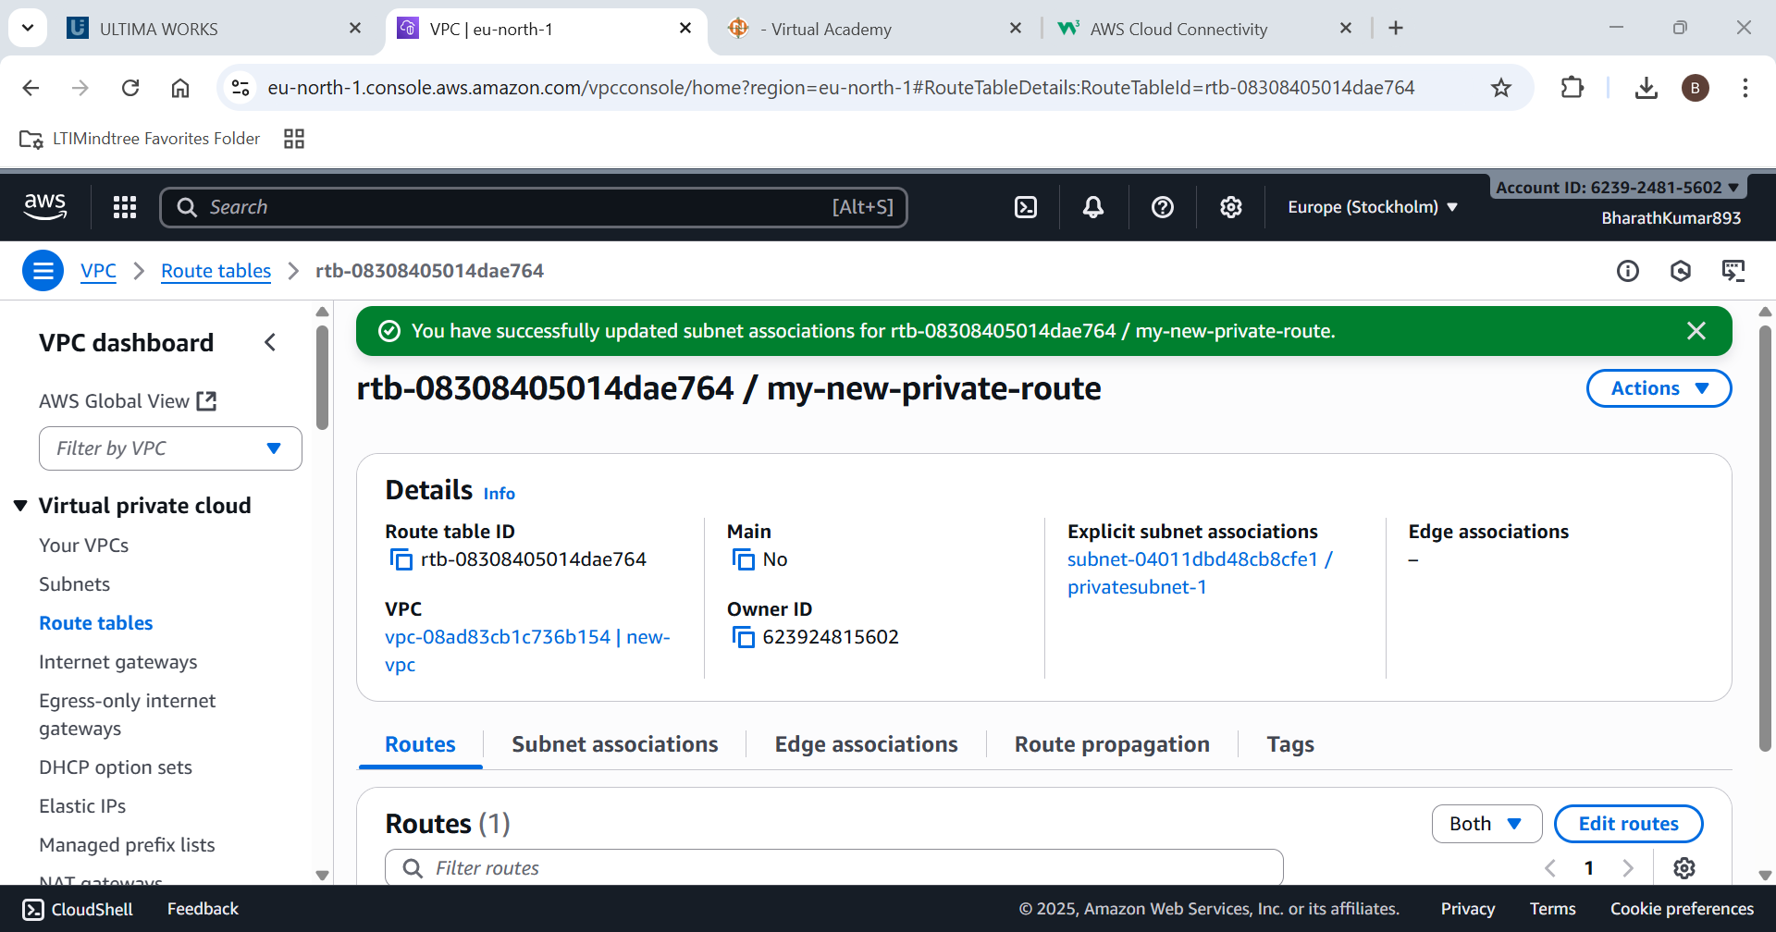

Use resource map for checking

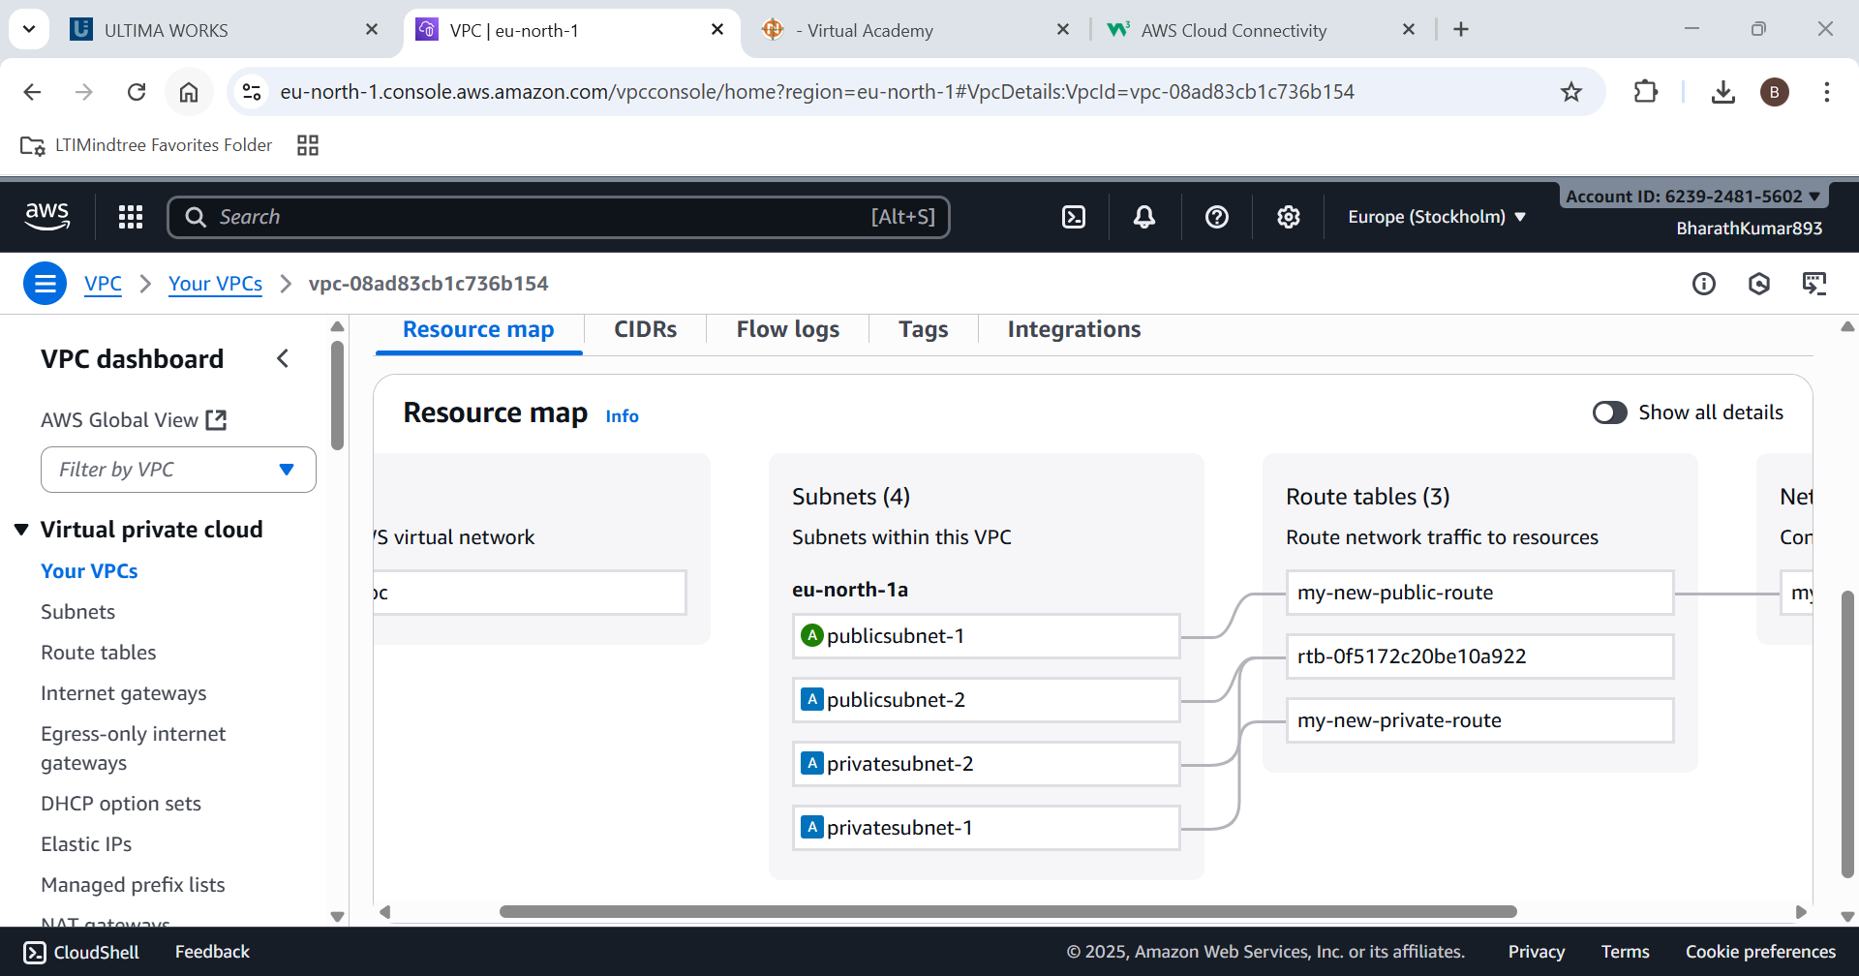

Go to NAT gateways

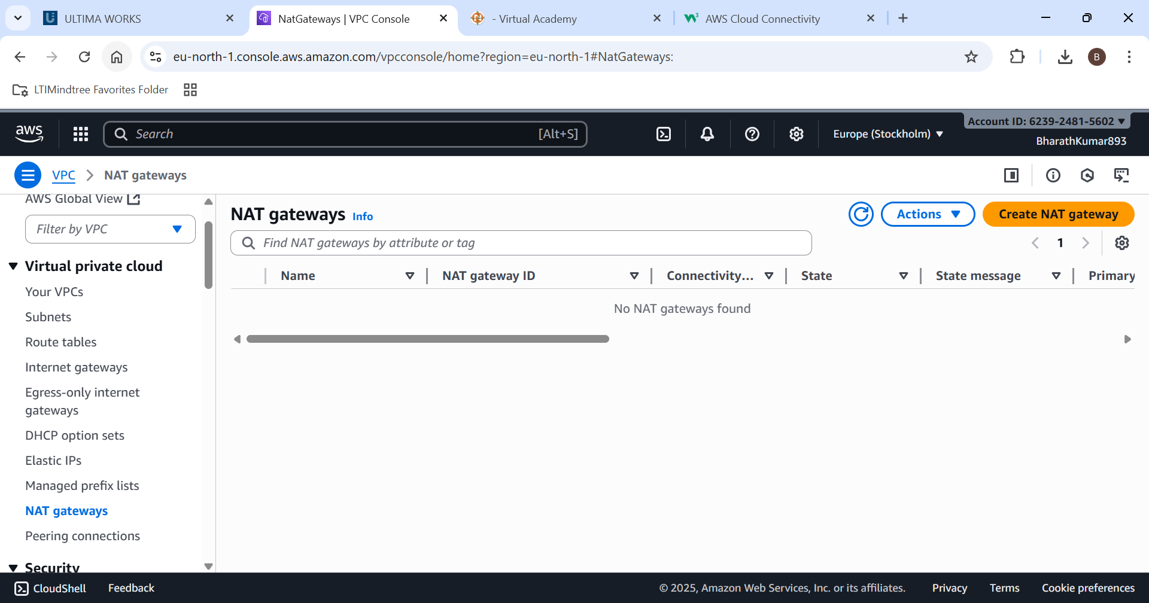

Create the NAT gateway in public subnet

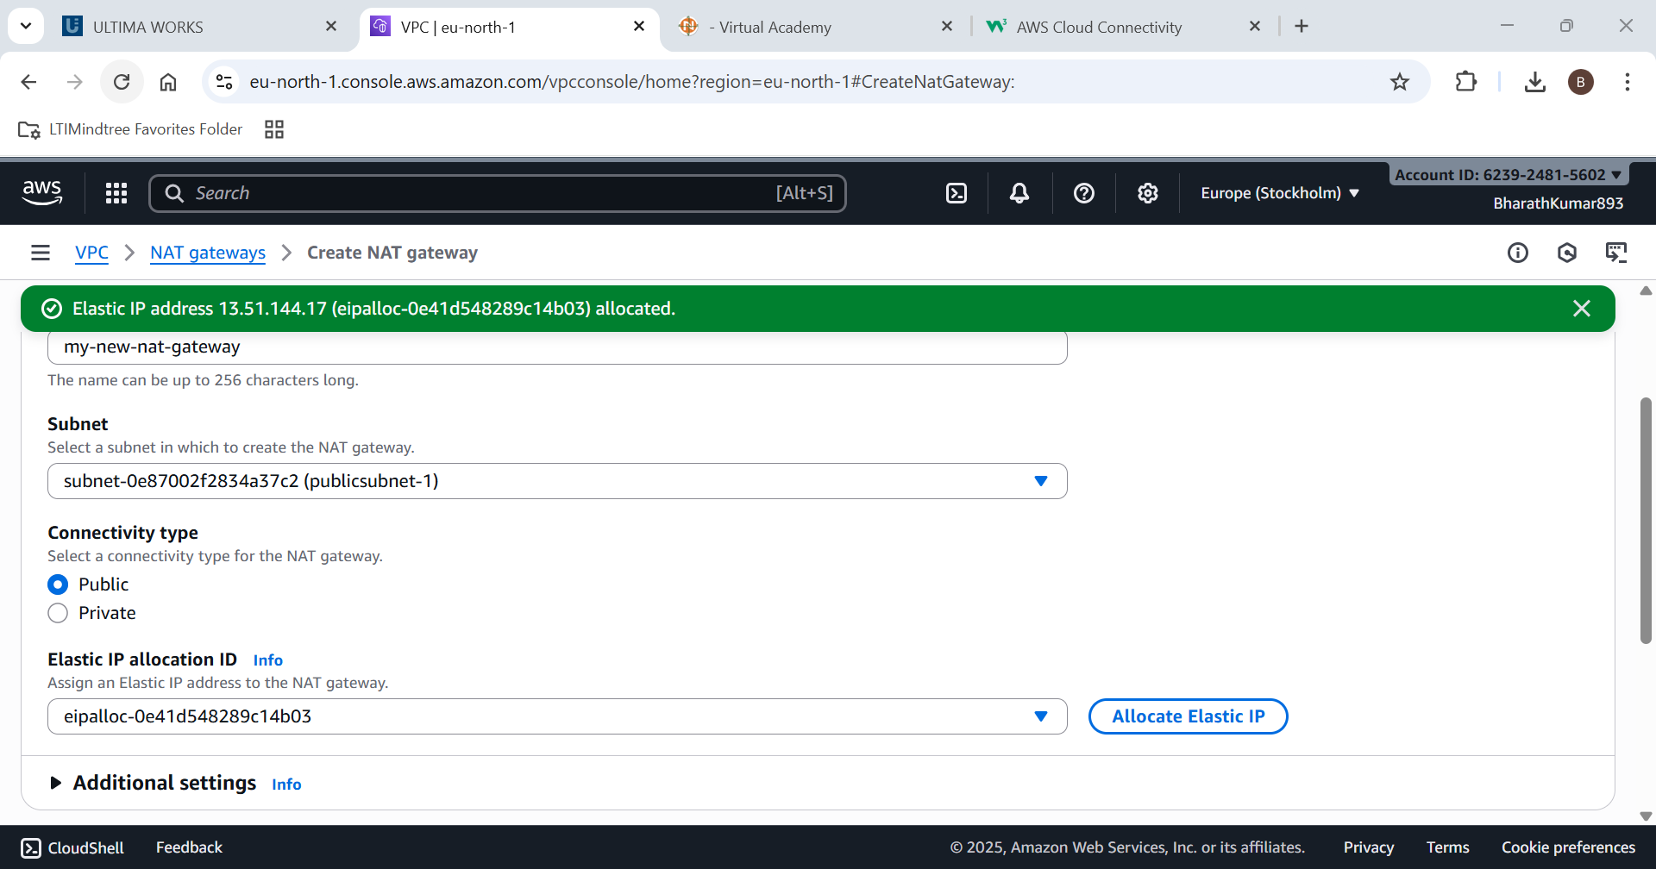

Nat Gateway is created successfully

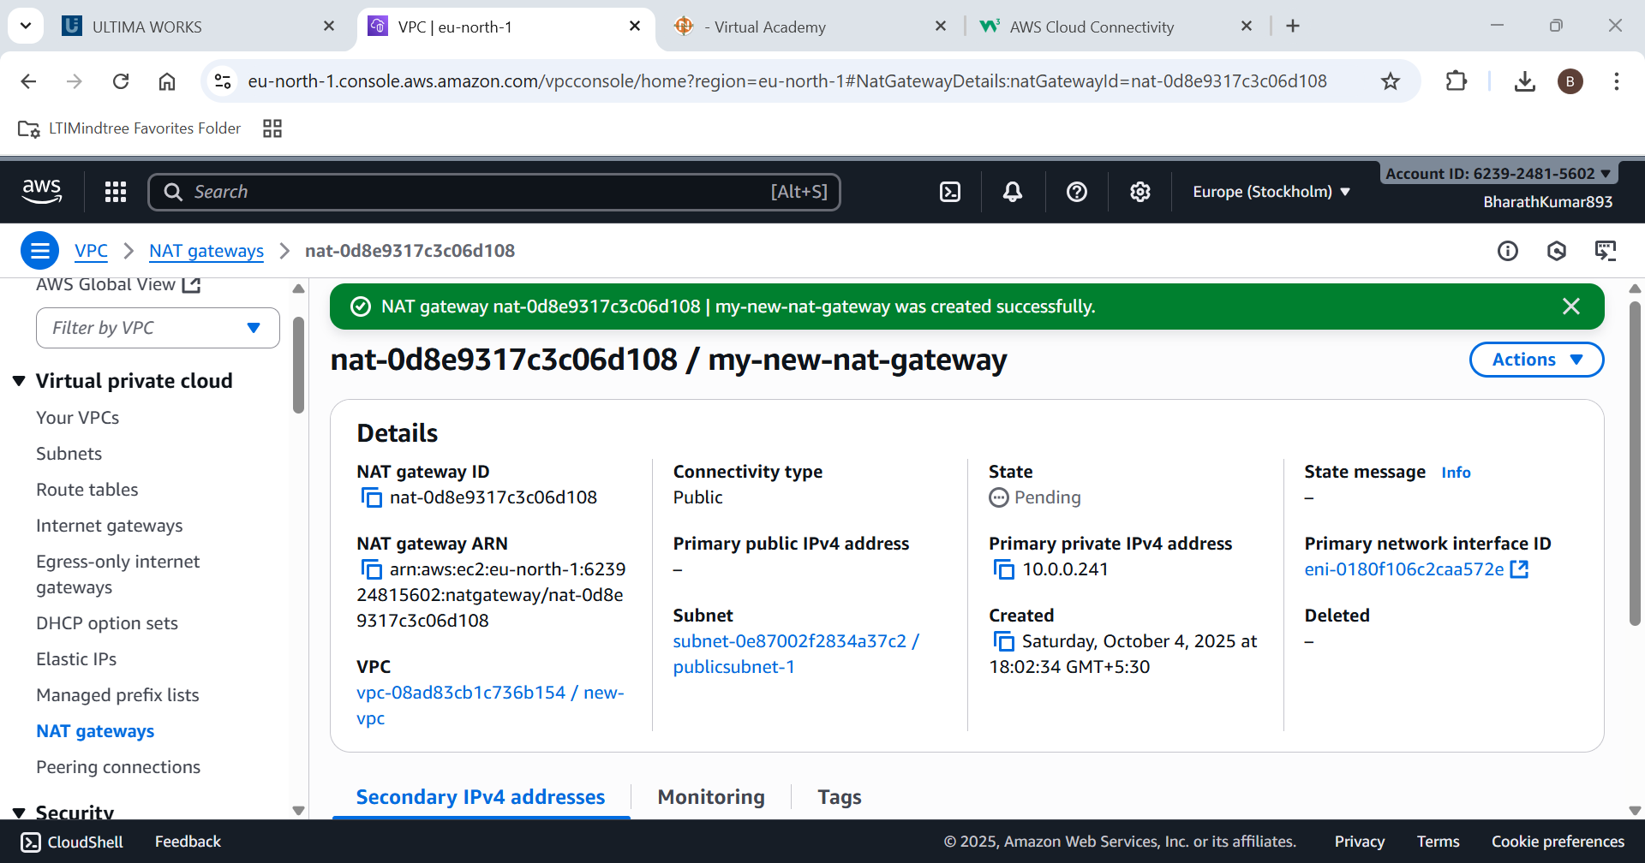

Edit routes in Private subnet connect it to Nat gateway

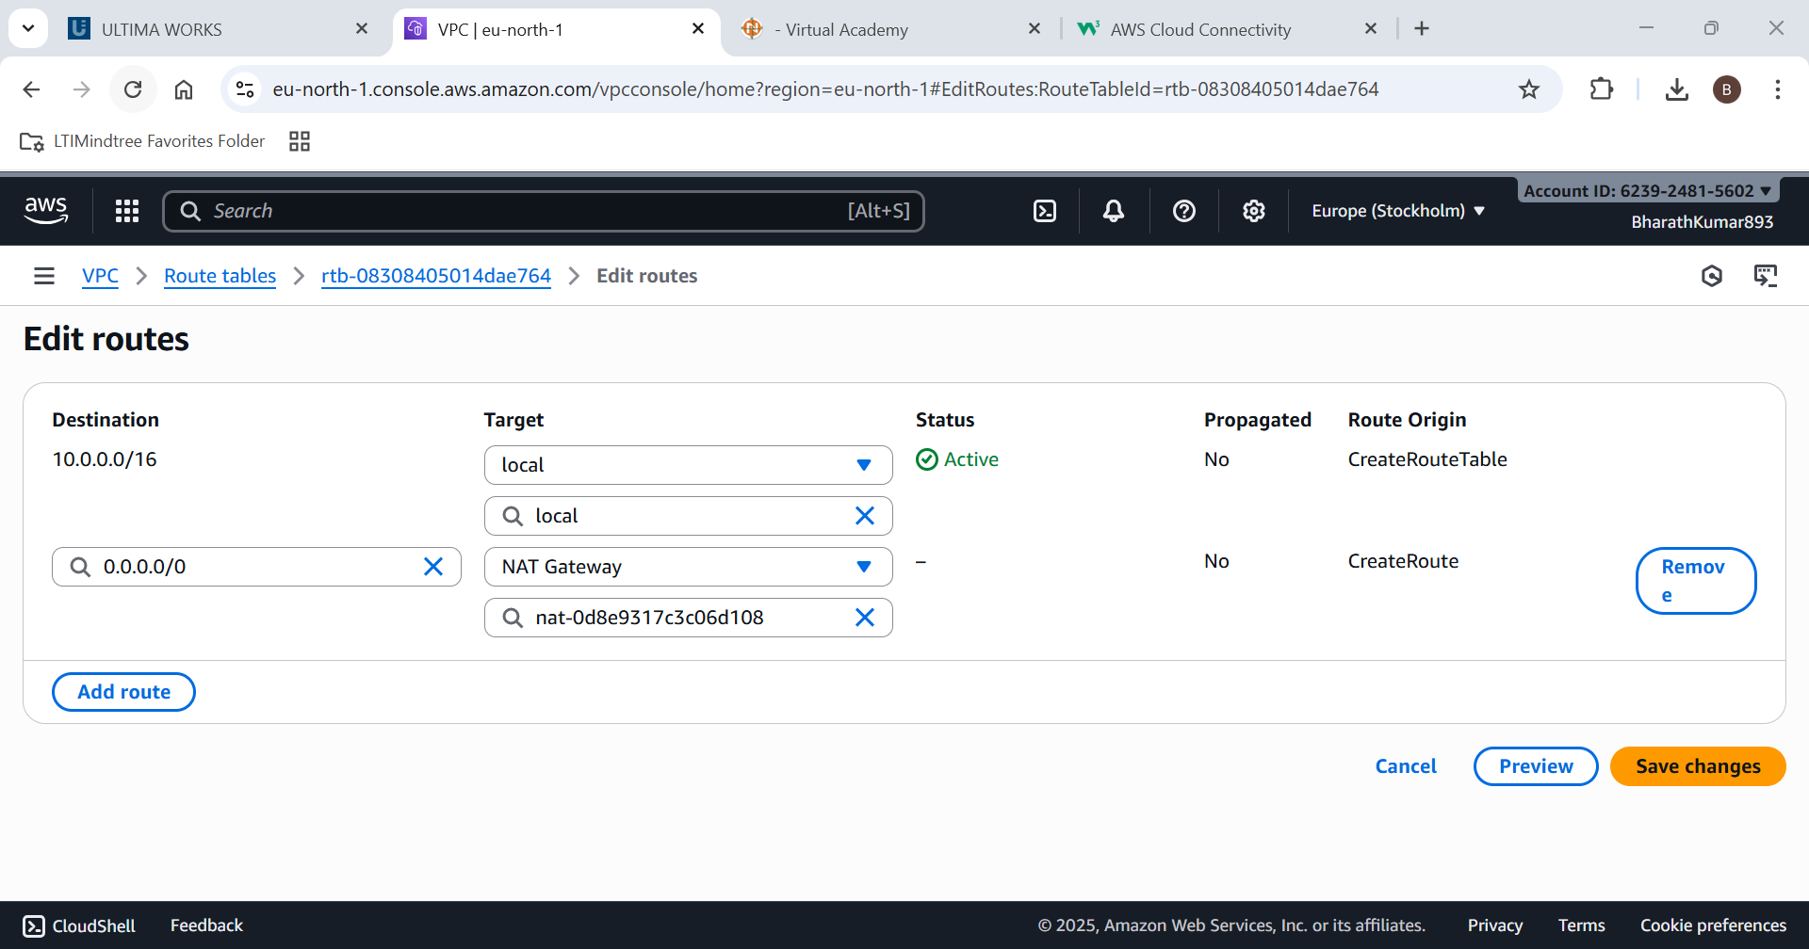

Use the public EC2 instance and check for internet connectivity

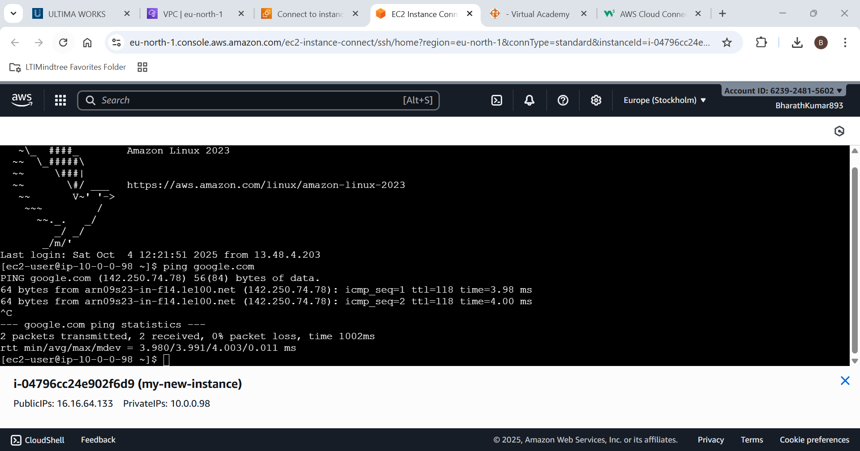

Now create and configure the private key

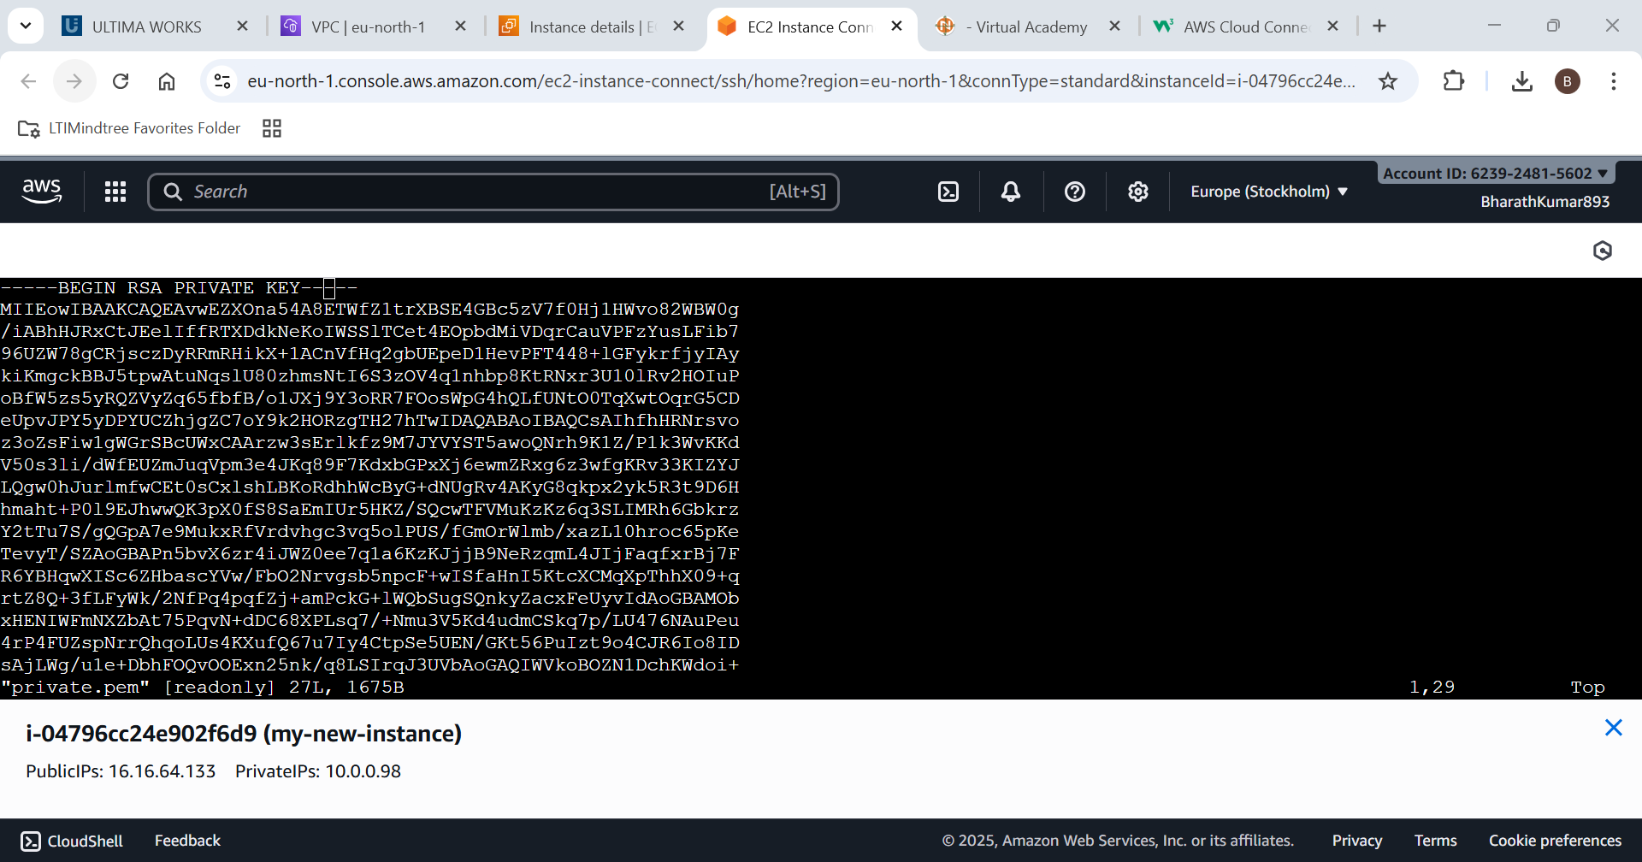

Now do SSH for private EC2 instance

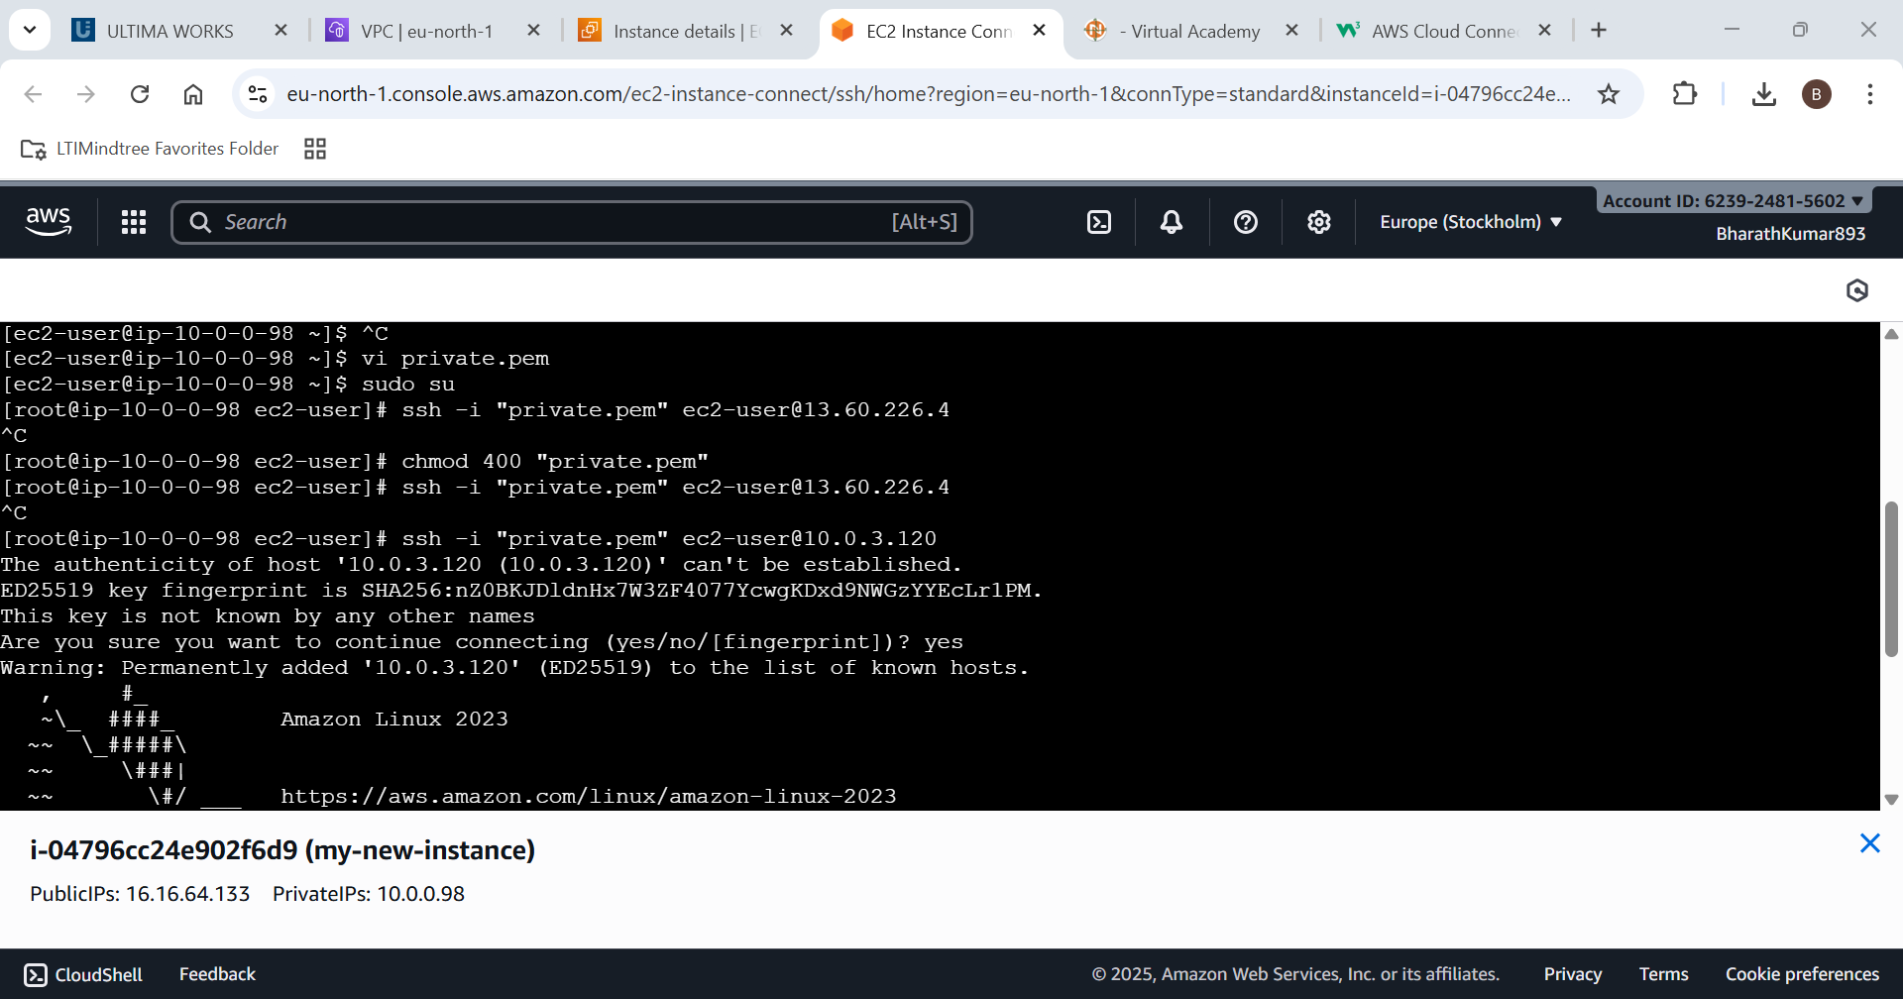

Now try using internet form private EC2 instance .

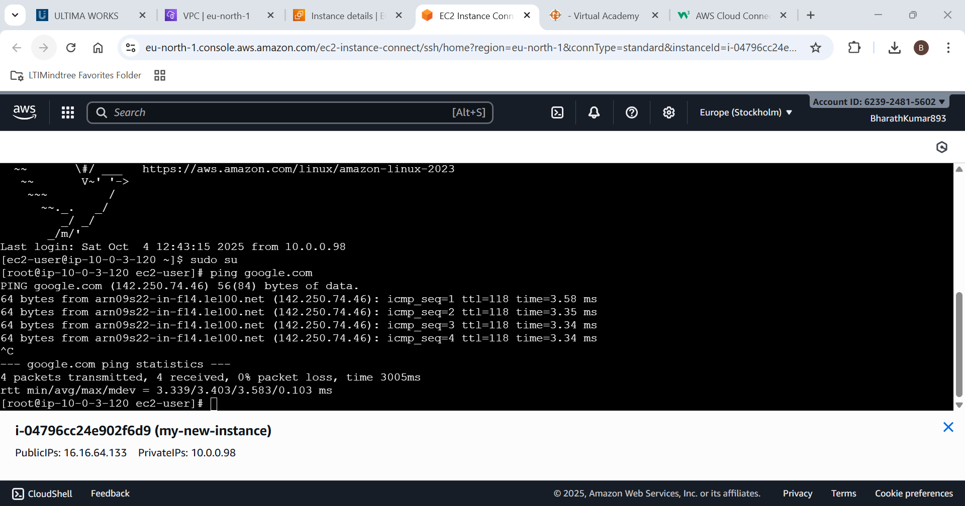

Internet is accessible from private EC2 instance.

1. Allocate and associate an Elastic IP with an EC2 instance.

Go the network and security > Elastic Ip

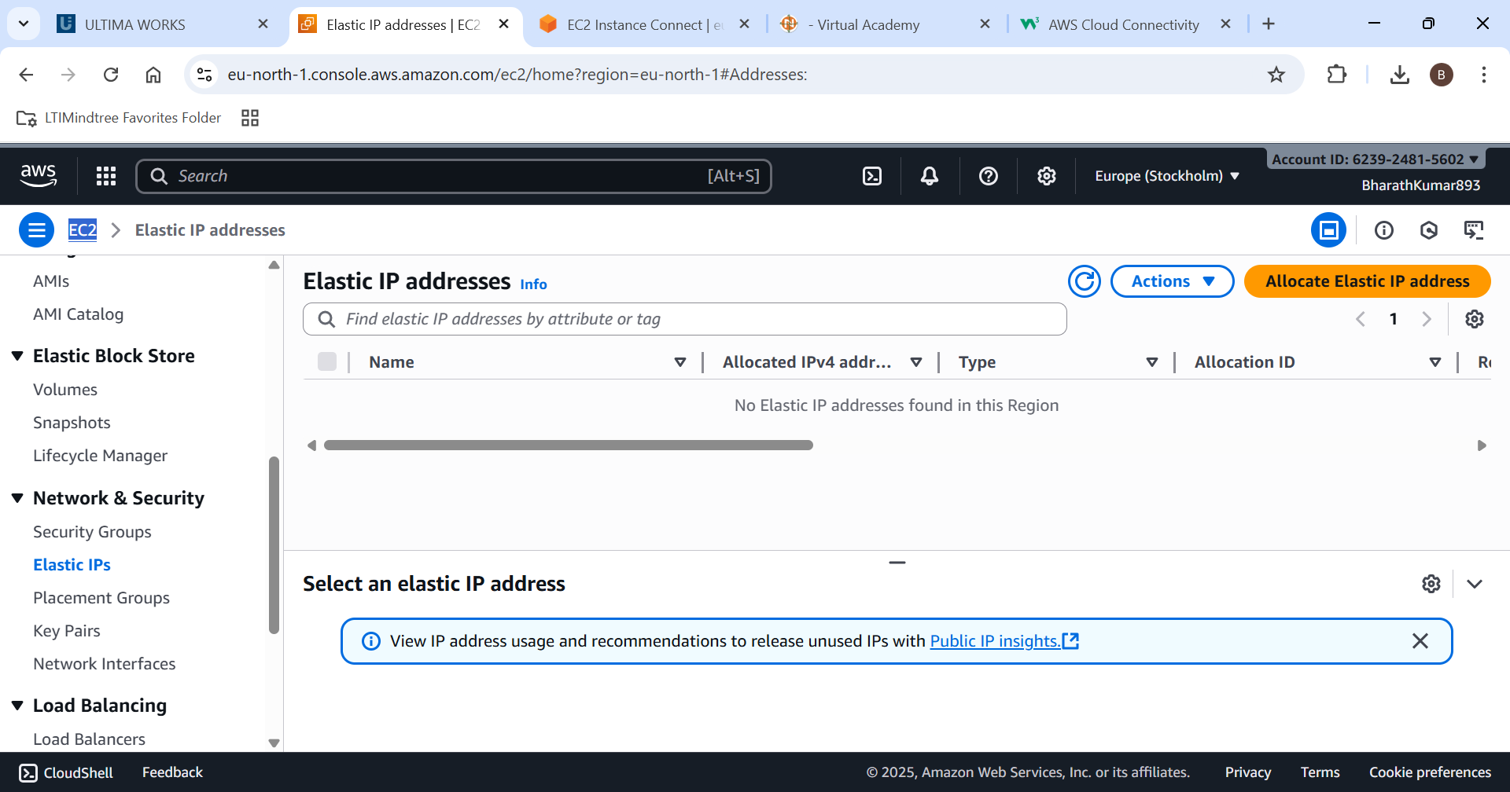

Allocate one EIP for EC2

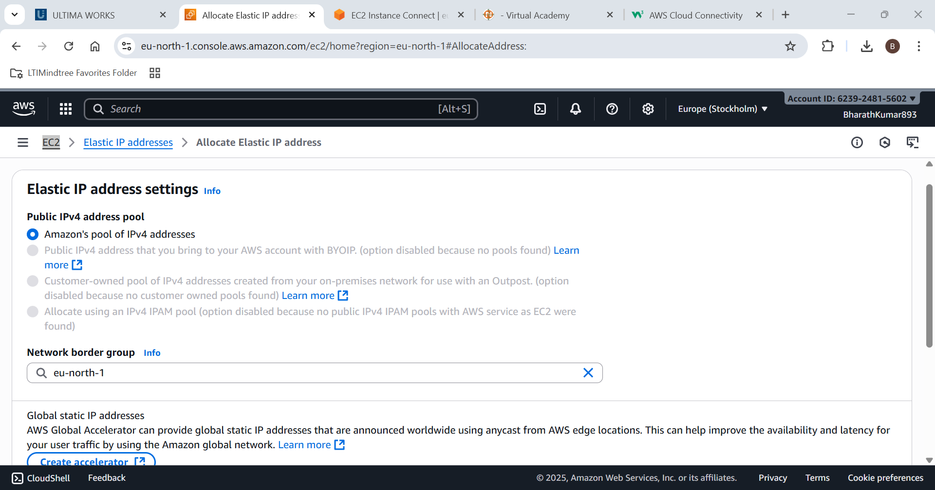

Now Associate it with the EC2 instance.

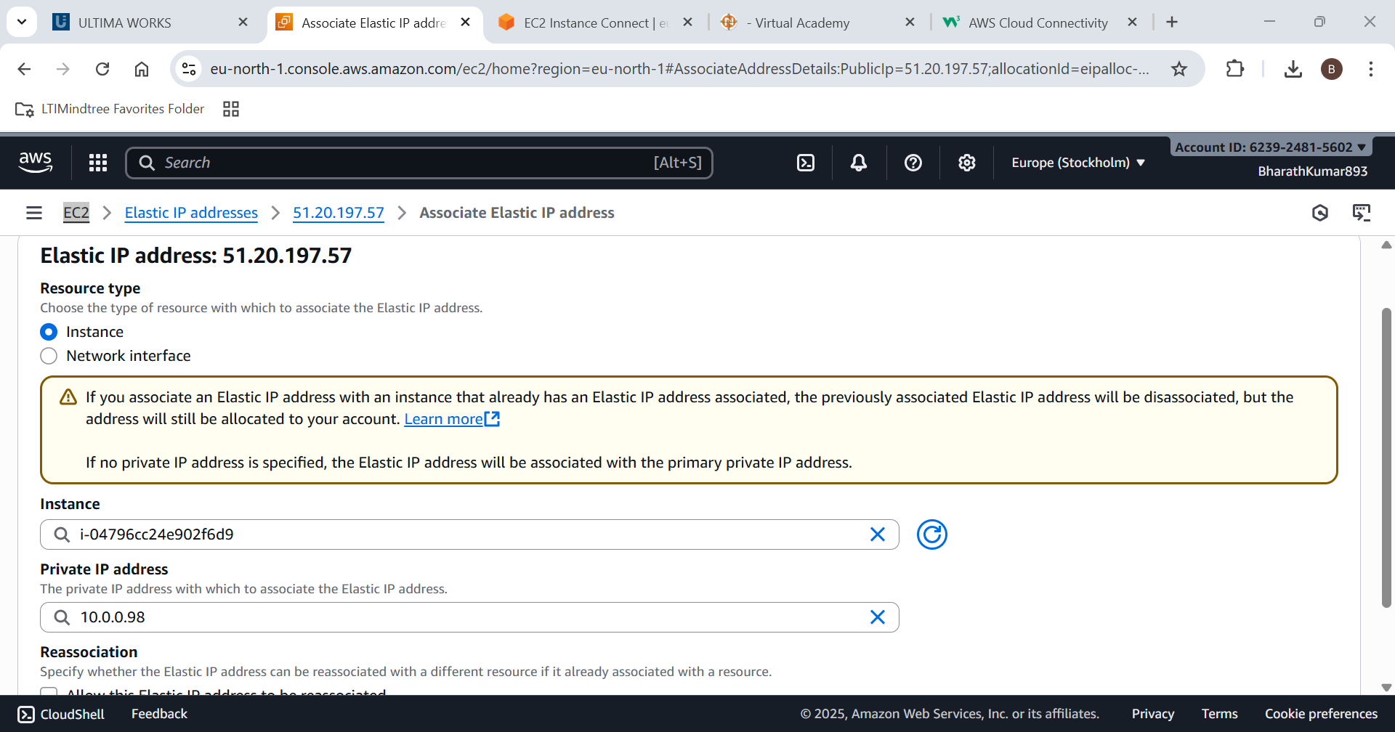

EIP created successfully

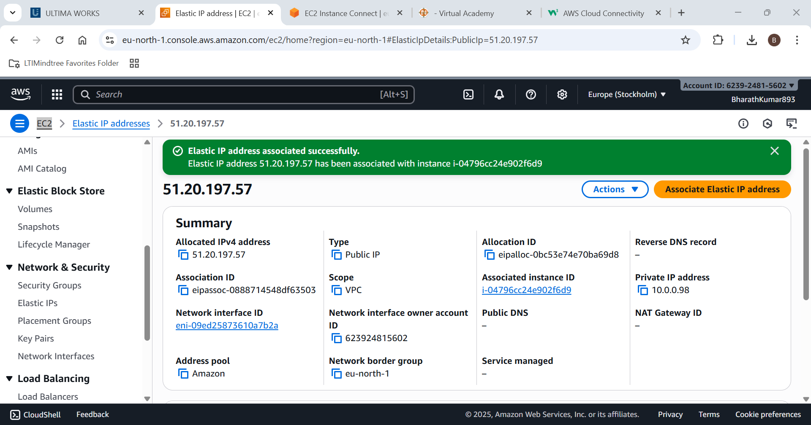

Verify in the EC2 instance for EIP.

